
Bu rasmda "Kursni muvaffaqiyatli tugatish uchun foydali maslahatlar" (Helpful Tips for Course Completion) keltirilgan. Bu infografika, ayniqsa, onlayn kurslarni (masalan, rasmda ko'rsatilgan IBM Skills Network kurslarini) o'qiyotganda intizomli bo'lish va oxiriga yetkazish uchun qo'llanmadir.
Rasm 5 ta asosiy qadamdan iborat. Ularning har birini batafsil tushuntirib beraman:

1. Kurs tarkibi bilan tanishib chiqing (Familiarize yourself with the course content)
O'qishni boshlashdan oldin nimalarni o'rganishingizni bilib olishingiz kerak.
- Modullarni ko'zdan kechiring: Kurs qanday bo'limlardan iborat ekanligini va har birining maqsadini tushunib oling.
- Mavzularni tushuning: Qanday mavzular o'tilishi va unga qanday qo'shimcha materiallar (video, matn, test) ilova qilinganini ko'ring.
- Reja tuzish uchun g'oyalarni bog'lang: Kursning umumiy tuzilishini tushunib, o'zingiz uchun "yo'l xaritasi"ni chizing.

2. Reja tuzing va vaqt jadvalini belgilang (Form your plan and make a rough timeline)
Tartibsizlik – onlayn o‘qishning eng katta dushmani.
- Vaqtni chamalang: Har bir modulni tugatish uchun qancha vaqt ketishini ko'rib chiqing (ko'pincha kurslarda bu yozilgan bo'ladi).
- Maqsad qo'ying: Har bir modul uchun aniq tugatish vaqtini belgilang.
- Dedlayn (Deadline) belgilang: Kursni to'liq tugatish uchun oxirgi muddatni aniqlang.
- Kunlik o'qish vaqti: Kun davomida aynan qaysi vaqtda shug'ullanishingizni rejalashtiring (masalan, har kuni soat 20:00 dan 21:00 gacha).

3. O'rganish jarayonini faol boshqaring (Actively manage your learning)
Shunchaki videoni ko'rib qo'yish yetarli emas, faol ishtirok etish kerak.
- Mustaqil vazifalar:
  - Konspekt (qaydlar) yozib boring.
  - Videolarning matnini (transkriptini) yuklab oling va muhim joylarini belgilang.
  - Barcha laboratoriya (amaliy) ishlarini bajaring.
  - Yangi atamalarni lug'atdan o'rganing.
- Yordam olish: Muhokama forumlarida qatnashing, savol bering va boshqalar bilan fikr almashing.
- Testlarni topshirish:
  - Testdan oldin yozgan konspektlaringizni o'qing.
  - Mashq testlarini yechib ko'ring.
  - Xato qilgan savollaringiz bo'yicha qaytadan o'qing yoki videoni qayta ko'ring.
  - Testdan o'tmaguncha qayta topshiring.

4. Do'stlaringiz va oilangiz bilan kurs haqida gaplashing (Talk with your friends and family)
Bu sizga motivatsiya va mas'uliyat beradi.
- Mas'uliyatli bo'ling: Boshqalarga "Men shu kursni o'qiyapman" deb aytish, uni tashlab qo'ymaslikka undaydi.
- Suhbatlashing: O'rgangan qiziqarli mavzularingizni ularga aytib bering (kimgadir tushuntirish – eng yaxshi o'rganish usulidir).
- Fikr almashing: Ularning ham fikrini eshiting, bu sizga yangi qarashlarni berishi mumkin.

5. Rejangizga amal qiling (Follow your plan)
Eng muhimi – boshlagan ishni davom ettirish.
- Motivatsiyani saqlang: Tuzgan rejangizdan og'ishmaslikka harakat qiling.
- Kichik maqsadlar: 2-qadamda belgilagan kichik maqsadlaringizga erishing.
- O'zingizni mukofotlang: Biror bo'limni yoki kursni tugatganingizda o'zingizni biror narsa bilan (masalan, shirinlik, sayr yoki hordiq bilan) xursand qiling.
Qisqacha xulosa: Bu rasm sizga reja asosida o'qishni, faol bo'lishni va atrofingizdagilar bilan muloqot qilish orqali o'qish samaradorligini oshirishni maslahat bermoqda.

Lesson Overview: Defining Data Science
In this lesson, “Defining Data Science,” you begin your journey with an introduction to Data Science. Through the videos in this lesson, you will learn what data science is, the data scientist’s role in an organization, and what makes a skilled data scientist. You will hear from experts on how to acquire these skills.
Asset name and type | Description
“What is Data Science” video | Hear from data science experts in the field explaining what data science is to them.
“Fundamentals of Data Science” video | This animated video touches upon some of the core attributes of data science, such as data analysis, varied sources of data, the data science process, the qualities of a good data scientist, and the role of a data scientist in an organization.
“The Many Paths to Data Science” video | Hear from graduate students and professionals discuss what led them into the field and why data science is a good fit for them.
“The sexiest job in the 21st Century” reading | Read an excerpt from the “Getting Started with Data Science” textbook and learn about the qualities of data science that attract people to the profession.
Practice quiz | Test your understanding of the previous reading.
“Advice for New Data Scientists” video | Hear from professor and author Dr. Murtaza Haider, PhD, an associate professor from the Ted Rogers School of Management, give his perspective on how to gain a competitive analysis in the data science field.
Practice quiz | Take a practice quiz to evaluate how well you’ve understood the material presented in this lesson.
Glossary | Use this glossary of terms to review the terminology presented in this lesson.
Graded quiz | Test your knowledge from this lesson by taking the graded quiz.
Bu matn sizning Data Science (Ma'lumotlar fani) bo‘yicha kursingizning birinchi darsi – "Data Science'ni aniqlash" (Defining Data Science) bo‘limining umumiy rejasi va tarkibi haqida ekan.
Bu darsning maqsadi: Data Science nima ekanligi, soha mutaxassisining tashkilotdagi o‘rni va qanday qilib malakali mutaxassis bo‘lish mumkinligini tushuntirishdir.
Quyida dars tarkibidagi materiallarning o‘zbek tilidagi qisqacha mazmuni bilan tanishishingiz mumkin:

1. Videodarslar (Asosiy o‘rganish manbalari)
- "What is Data Science" (Data Science nima): Soha ekspertlarining Data Science ular uchun nimani anglatishi haqidagi fikrlarini eshitasiz. Bu umumiy tushuncha hosil qilish uchun.
- "Fundamentals of Data Science" (Data Science asoslari): Bu animatsion video bo‘lib, u sohaning asosiy jihatlarini qamrab oladi:
  - Ma'lumotlar tahlili.
  - Turli xil ma'lumot manbalari.
  - Data Science jarayoni.
  - Yaxshi mutaxassisning sifatlari va uning tashkilotdagi o‘rni.
- "The Many Paths to Data Science" (Data Science'ga eltuvchi ko‘plab yo‘llar): Magistratura talabalari va professionallar bu sohaga qanday kirib kelganliklari va nega bu soha ular uchun mos ekanligi haqida gapirib berishadi. Bu motivatsiya olish uchun yaxshi.
- "Advice for New Data Scientists" (Yangi boshlovchilar uchun maslahat): Professor va muallif Dr. Murtaza Haider (Ted Rogers boshqaruv maktabi dotsenti) bu sohada raqobatbardosh bo‘lish uchun qimmatli maslahatlar beradi.

2. O‘qish uchun material (Reading)
- "The sexiest job in the 21st Century" (XXI asrning eng jozibali kasbi): "Getting Started with Data Science" darsligidan parcha. Unda nega odamlar bu kasbga qiziqishi va uning jozibali tomonlari haqida so‘z boradi.

3. Bilimni tekshirish (Quizzes)
- Practice quiz (Mashq testi - 2 ta):
  - O‘qilgan maqola ("Sexiest job") bo‘yicha tushunchangizni tekshirish uchun.
  - Umumiy dars materiallari (videolar va ma'lumotlar) bo‘yicha o‘zlashtirish darajangizni baholash uchun.
Eslatma: Bular baholanmaydi, shunchaki mashq uchun.
- Graded quiz (Baholanadigan test): Bu darsning yakuniy testi. Buning natijasi sertifikat olishingizga ta'sir qiladi.

4. Qo'shimcha (Glossary)
- Glossary (Atamalar lug‘ati): Dars davomida ishlatilgan yangi terminlarning (atamalarning) izohli lug‘ati. Buni ko'chirib olish yoki saqlab qo'yish tavsiya etiladi.
Tavsiyam:
Oldingi rasmda (infografikada) ko'rganimizdek, avval videolarni diqqat bilan ko'ring, muhim joylarini yozib oling (note-taking), keyin lug'atni ko'zdan kechiring va eng oxirida Graded quizni ishlang. Omad!

Data Science is a process, not an event. It is the process of using data to understand different things, to understand the world. For me is when you have a model or hypothesis of a problem, and you try to validate that hypothesis or model with your data. Data science is the art of uncovering the insights and trends that are hiding behind data. It's when you translate data into a story. So use storytelling to generate insight. And with these insights, you can make strategic choices for a company or an institution.
Data science is a field about processes and systems to extract data from various forms of whether it is unstructured or structured form. Data science is the study of data. Like biological sciences is a study of biology, physical sciences, it's the study of physical reactions. Data is real, data has real properties, and we need to study them if we're going to work on them. Data Science involves data and some science. The definition or the name came up in the 80s and 90s when some professors were looking into the statistics curriculum, and they thought it would be better to call it data science. But what is Data Science?
I'd see data science as one's attempt to work with data, to find answers to questions that they are exploring. In a nutshell, it's more about data than it is about science. If you have data, and you have curiosity, and you're working with data, and you're manipulating it, you're exploring it, the very exercise of going through analyzing data, trying to get some answers from it is data science. Data science is relevant today because we have tons of data available. We used to worry about lack of data. Now we have a data deluge. In the past, we didn't have algorithms, now we have algorithms.
In the past, the software was expensive, now it's open source and free. In the past, we couldn't store large amounts of data, now for a fraction of the cost, we can have gazillions of datasets for a very low cost. So, the tools to work with data, the very availability of data, and the ability to store and analyze data, it's all cheap, it's all available, it's all ubiquitous, it's here. There's never been a better time to be a data scientist.

Bu matn (videoning transkripti) "Data Science o'zi nima?" degan savolga chuqur va har tomonlama javob beradi. Unda soha mutaxassislarining fikrlari jamlangan bo‘lib, asosiy g‘oyalarni quyidagicha tushuntirish mumkin:

1. Data Science – bu jarayon, shunchaki hodisa emas
Data Science bir martalik ish emas, balki davomiy jarayondir.
- Maqsad: Dunyoni va atrofimizdagi voqealarni ma'lumotlar orqali tushunish.
- Ilmiy yondashuv: Sizda biror muammo bo'yicha gipoteza (taxmin) yoki model bo'ladi va siz ma'lumotlar yordamida bu taxmin to'g'ri yoki noto'g'ri ekanligini tekshirasiz.

2. Ma'lumotlar ortidagi hikoya (Storytelling)
Data Science faqat raqamlar bilan ishlash emas, bu san'atdir.
- Ma'lumotlar ichida yashiringan qonuniyatlar va "insight"larni (muhim xulosalarni) topish kerak.
- Hikoya so'zlash: Topilgan raqamlarni oddiy tilda tushunarli "hikoya"ga aylantirib berish. Bu rahbarlarga yoki kompaniyalarga to'g'ri strategik qarorlar qabul qilishda yordam beradi.
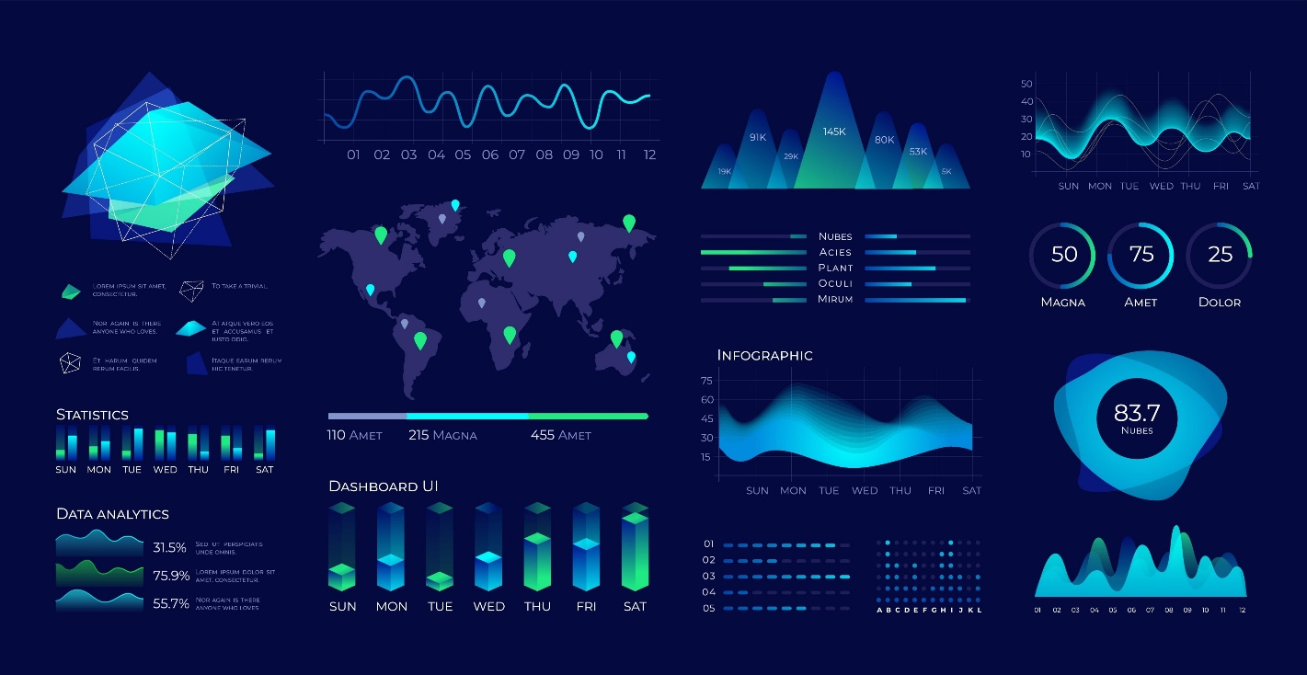

3. Ma'lumotlarni o'rganish fani
Biologiya tirik organizmlarni o'rgangani kabi, Data Science ma'lumotlarni o'rganadi.
- Ma'lumotlar ikki xil bo'ladi:
  - Strukturalashgan (jadval ko'rinishida, tartibli).
  - Strukturalashmagan (video, rasm, matn, tartibsiz).
- Data Science – bu turli ko'rinishdagi ma'lumotlarni yig'ib olish va ularni qayta ishlash tizimidir.

4. Qiziquvchanlik (Curiosity)
Mutaxassislardan biri Data Science'ni "javob izlashga bo'lgan urinish" deb ta'riflaydi.
- Bu fan ko'proq ma'lumot haqida, "science" (fan) haqida emas.
- Agar sizda ma'lumot bo'lsa va qiziquvchanlik bo'lsa, siz ma'lumotni "kovlab", uni tahlil qilib, savollaringizga javob topsangiz – bu Data Science bilan shug'ullanishdir.

5. Nega aynan hozir? (Data Science davri)
Video nima uchun Data Science hozirgi kunda bunchalik dolzarb ekanligini taqqoslash orqali tushuntiradi:
O'tmishda | Hozirda
Ma'lumot yetishmasligi muammo edi. | Ma'lumotlar toshqini (Data deluge) mavjud.
Algoritmlar yo'q edi. | Kuchli algoritmlar mavjud.
Dasturlar qimmat edi. | Dasturlar bepul va ochiq kodli (Open Source).
Ma'lumotni saqlash qimmat va qiyin edi. | Katta hajmdagi ma'lumotni saqlash juda arzon.
Xulosa: Hamma sharoitlar (ma'lumot, vositalar, arzon xotira) mavjudligi sababli, Data Scientist bo'lish uchun tarixdagi eng qulay vaqt aynan hozirgi davrdir.

[SOUND] [MUSIC] Data science didn't really exist when I was growing up. It's not something that I ever woke up and said, I want to be a data scientist when I grow up. No, it didn't exist. I didn't know I would be working in data science. When I grew up, there isn't that field called data science. And I think it's really new. Data science didn't exist until 2009, 2011.
Someone like DJ Patil or Andrew Gelman coined the term. Before that, there was statistics. And I didn't want to be any of those. I want to be in business. And then I found data science a heck of a lot more interesting. I studied statistics, that's how I started. I went through many different stages in my life where I wanted to be a singer and then a doctor.
And then I realized that I was good at math. So I chose an area that was focused on quantitative analysis. And from then I do think that I wanted to work with data. Not necessarily data science as it's known today. The first time that I had contact with data science, when I was my first year as a mechanical engineering. And strategic consulting firms, they use data science to make decisions. So it was my first contact with data science.
I had a complicated problem that I needed to solve, and the usual techniques that we had at that time couldn't help with that problem. I graduated with a math degree in the worst possible time, right after the economic crisis, and you actually had to be useful to get a job. So I went and got a degree in statistics. And then I worked enough jobs that were called data scientist that I suddenly became one. My undergraduate degree was in business, and I majored in politics, philosophy, and economics. And then I did a masters in business analytics at New York University at the Stern School of Business. When I left my undergrad, the first company I joined, it turned out that they were analyzing electronic point of sale data for retail manufacturers.
And what we were doing was data science. But we only really started using that term much later. In fact, I'd say four or five years ago is when we started calling it analytics and data science. I had several options for my internship here in Canada. And one of the options was to work with data science. I used to work with project development. But I think that was a good choice.
And then I start my internship with data science. I'm a civil engineer by training, so all engineers work with data. I would say the conventional use of data science in my life started with transportation research. I started building large models trying to forecast traffic on streets, trying to determine congestion and greenhouse gas emissions or tailpipe emissions. So I think that's where my start was. And I started building these models when I was a graduate student at the University of Toronto. Started working with very large data sets, looking at household samples of, say, 150,000 households from half a million trips.
And that, too, I'm speaking from mid 90s when this was supposed to be a very large data set, but not in today's terms. But that's how I started. I continued working with it. And then I moved to McGill University where I was a professor of transportation engineering. And I built even bigger data models that involved data and analytics. And so I would say, yes, transportation research brought me to data science. [MUSIC]

Bu matn (videotranskript) turli xil mutaxassislarning Data Science sohasiga qanday kirib kelganliklari haqidagi shaxsiy hikoyalaridan iborat.
Matnning asosiy mazmuni shundaki, Data Science sohasiga kirishning yagona va aniq yo'li yo'q. Mutaxassislar juda xilma-xil sohalardan kelishgan.
Quyida asosiy nuqtalarni keltirib o‘taman:

1. "Bunday kasb yo‘q edi"
Deyarli barcha spikerlar bir xil fikrni aytishdi: Ular yoshligida "Men katta bo'lsam Data Scientist bo'laman" deb orzu qilishmagan.
- Sababi: Ular ulg‘aygan paytda bunday sohaning o‘zi mavjud emas edi.
- Data Science atamasi taxminan 2009-2011 yillarda ommalasha boshlagan (DJ Patil va Andrew Gelman tomonidan). Ungacha bu soha asosan "Statistika" yoki "Analitika" deb atalgan.

2. Turli xil kelib chiqish tarixi (Background)
Videodagi insonlar bu sohaga turlicha yo‘llar bilan kelib qolishgan:
- Statistika va Matematika: Bir kishi iqtisodiy inqiroz (krizis) paytida o'qishni bitirgani va ish topish uchun "foydaliroq" soha kerakligi sababli statistikani tanlagan.
- Biznes va Iqtisodiyot: Boshqasi biznes, siyosat va falsafani o'qigan, keyin esa biznes-analitika orqali bu sohaga o'tgan.
- Muhandislik (Injiniring):
  - Biri mexanik muhandis bo'lib o'qiyotganda strategik konsaltingda ma'lumotlar bilan ishlagan.
  - Yana biri (transport muhandisi) transport qatnovi va tirbandliklarni bashorat qiluvchi modellar tuzish orqali Data Science'ga kirib kelgan.

3. Nomlanmasdan oldin ishlash
Ko'pchilik mutaxassislar aslida "Data Scientist" deb atalishidan oldin ham shu ishni qilishgan.
- Masalan, chakana savdo (retail) ma'lumotlarini tahlil qilishgan yoki transport modellarini tuzishgan.
- Ular shunchaki o'zlarini "analitik" yoki "muhandis" deb hisoblashgan, lekin qilayotgan ishlari aynan Data Science edi.

4. Qiziqishning o'zgarishi
Ba'zilar yoshligida qo'shiqchi yoki shifokor bo'lishni xohlashgan, lekin keyinchalik matematikaga qiziqib qolishgan yoki murakkab muammolarni yechish jarayoni ularni o'ziga rom etgan.
Xulosa:
Bu matn sizga shuni anglatmoqchiki, Data Science – bu ochiq soha. Siz quruvchi bo'lasizmi, harbiymisiz yoki o'qituvchi – agar sizda ma'lumotlar (data) bo'lsa va muammolarni yechishga qiziqsangiz, sizning oldingizda Data Science eshiklari ochiq. Soha vakillari aytganidek: "Hamma muhandislar ma'lumot bilan ishlaydi, demak ular qaysidir ma'noda Data Scientistdirlar."

Data Science: The Sexiest Job in the 21st Century
In the data-driven world, data scientists have emerged as a hot commodity. The chase is on to find the best talent in data science. Already, experts estimate that millions of jobs in data science might remain vacant for the lack of readily available talent. The global search for skilled data scientists is not merely a search for statisticians or computer scientists. In fact, the firms are searching for well-rounded individuals who possess the subject matter expertise, some experience in software programming and analytics, and exceptional communication skills.
Our digital footprint has expanded rapidly over the past 10 years. The size of the digital universe was roughly 130 billion gigabytes in 1995. By 2020, this number will swell to 40 trillion gigabytes. Companies will compete for hundreds of thousands, if not millions, of new workers needed to navigate the digital world. No wonder the prestigious Harvard Business Review called data science the sexiest job in the 21st century.
A report by the McKinsey Global Institute warns of huge talent shortages for data and analytics. By 2018, the United States alone could face a shortage of 140,000 to 190,000 people with deep analytical skills as well as 1.5 million managers and analysts with the know-how to use the analysis of big data to make effective decisions.
Because the digital revolution has touched every aspect of our lives, the opportunity to benefit from learning about our behaviors is more so now than ever before. Given the right data, marketers can take sneak peeks into our habit formation. Research in neurology and psychology is revealing how habits and preferences are formed and retailers like Target are out to profit from it. However, the retailers can only do so if they have data scientists working for them. "For this reason, it is like an arms race to hire statisticians nowadays", said Andreas Weigend, the former chief scientist at Amazon.com.
There is still the need to convince the C-suite executives of the benefits of data and analytics. It appears that the senior management might be a step or two behind the middle management in being informed of the potential of analytics-driven planning. Professor Peter Fader, who manages the Customer Analytics Initiative at Wharton, knows that executives reach the C-suite without having to interact with data. He believes that the real change will happen when executives are well-versed in data and analytics.
SAP, a leader in data and analytics, reported from a survey that 92% of the responding firms in its sample experienced a significant increase in their data holdings. At the same time, three-quarters identified the need for new data science skills in their firms. Accenture believes that the demand for data scientists may outstrip supply by 250,000 in 2015 alone. A similar survey of 150 executives by KPMG in 2014 found that 85% of the respondents did not know how to analyze data. Most organizations are unable to connect the dots because they do not fully understand how data and analytics can transform their business, Alwin Magimay, head of digital and analytics for KPMG UK, said in an interview in May 2015.
Bernard Marr writing for Forbes also raises concerns about the insufficient analytics talent. There just aren't enough people with the required skills to analyze and interpret this information-transforming it from raw numerical (or other) data into actionable insights-the ultimate aim of any Big Data-driven initiative, he wrote. Bernard quotes a survey by Gartner of business leaders of whom more than 50% reported the lack of in-house expertise in data science.
Bernard reported on Walmart, which turned to crowd-sourcing for its analytics need. Walmart approached Kaggle to host a competition for analyzing its proprietary data. The retailer provided sales data from a shortlist of stores and asked the competitors to develop better forecasts of sales based on promotion schemes.
Given the shortage of data scientists, employers are willing to pay top dollars for the talent. Michael Chui, a principal at McKinsey, knows this too well. "Data science has become relevant to every company… There's a war for this type of talent," he said in an interview. Take Paul Minton, for example. He was making $20,000 serving tables at a restaurant. He had majored in math at college. Mr. Minton took a three-month programming course that changed everything. He made over $100,000 in 2014 as a data scientist for a web startup in San Francisco. Six figures, right off the bat… To me, it was astonishing, said Mr Minton.
Could Mr Minton be exceptionally fortunate, or are such high salaries the norm? Luck had little to do with it; the New York Times reported $100,000 as the average base salary of a software engineer and $112,000 for data scientists.

Bu matn Garvard Biznes Sharhi (Harvard Business Review) tomonidan "Data Science – XXI asrning eng jozibali (sexiest) kasbi" deb nomlangan mashhur maqolaga va umumiy bozor holatiga asoslangan.
Matn nega bu soha bunchalik talabgir ekanligi va nima uchun mutaxassislar yetishmayotganini tushuntiradi. Asosiy nuqtalar quyidagicha:

1. Iste'dodlar uchun ov (The Chase for Talent)
Hozirgi kunda Data Scientistlar "qaynoq tovar"ga aylangan.
- Muammo: Mutaxassislar juda kam. McKinsey instituti hisob-kitobiga ko'ra, AQShning o'zida chuqur analitik qobiliyatga ega 140,000 dan 190,000 gacha mutaxassis yetishmaydi.
- Kim kerak? Kompaniyalar shunchaki statistik olim yoki dasturchini qidirmayapti. Ularga "har tomonlama rivojlangan" (well-rounded) shaxslar kerak.
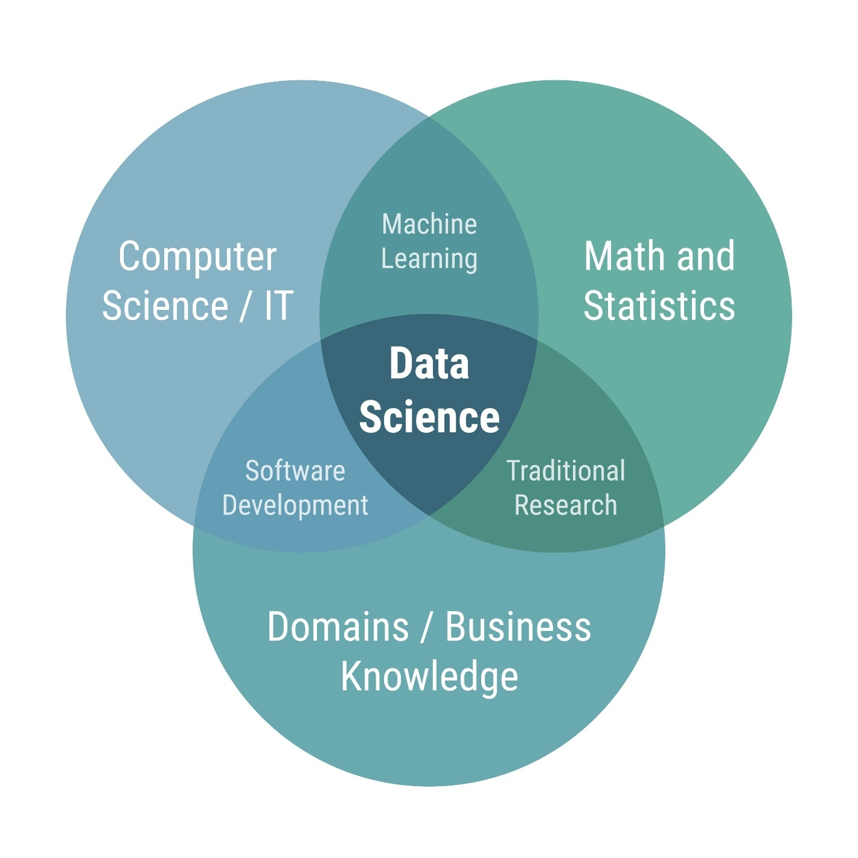
Shutterstock
Bunday mutaxassis 3 narsani birlashtirishi kerak: soha bilimi (biznes tushunchasi), dasturlash va a'lo darajadagi muloqot qobiliyati.

2. Ma'lumotlarning portlashi
Raqamli olamimiz juda tez kengaymoqda:
- 1995-yil: 130 milliard gigabayt.
- 2020-yil: 40 trillion gigabayt.
Bu ma'lumotlar ummonida suzish uchun "kapitanlar", ya'ni Data Scientistlar kerak.

3. Biznesdagi o'zgarishlar va Rahbariyat
Kompaniyalar (masalan, Target yoki Amazon) xaridorlarning odatlarini o'rganish uchun nevrologiya va psixologiyadan foydalanishmoqda.
- Qiyinchilik: Ko'plab yuqori lavozimli rahbarlar (C-suite executives) hali ham ma'lumotlarga asoslanib qaror qabul qilishni to'liq tushunishmaydi. O'rta bo'g'in menejerlari bu borada ilgarilab ketgan.
- Walmart misoli: Walmart o'zida yetarli mutaxassis topa olmagani uchun Kaggle platformasi orqali musobaqa uyushtirib, tashqaridan yordam (crowd-sourcing) olishga majbur bo'lgan.

4. Maoshlar va "Urush"
Hozir kompaniyalar o'rtasida mutaxassislar uchun "qurollanish poygasi" ketmoqda.
- Paul Minton hikoyasi: U restoranda ofitsiant bo'lib, yiliga $20,000 topardi. Matematikadan xabari borligi uchun 3 oylik dasturlash kursini o'qigach, San-Fransiskodagi startapda $100,000 dan ortiq maosh oladigan Data Scientistga aylandi.
- O'rtacha maosh: New York Times ma'lumotiga ko'ra, oddiy dasturchining o'rtacha maoshi $100,000 bo'lsa, Data Scientistniki $112,000 ni tashkil qiladi.
Xulosa:
Siz o'rganayotgan soha shunchaki "moda" emas, balki raqamli inqilobning zaruriy ehtiyojidir. Bozorga nafaqat kod yoza oladigan, balki ma'lumotlardan biznes uchun foyda chiqarib bera oladigan mutaxassislar kerak. Sizdagi o'qituvchilik va harbiy sohadagi tajriba (intizom va tushuntirish qobiliyati) bu kasbda sizga katta ustunlik berishi mumkin.

[Music] My advice to an aspiring data scientist is to be curious, extremely argumentative and judgmental. Curiosity is absolute must. If you're not curious, you would not know what to do with the data. Judgmental because if you do not have preconceived notions about things you wouldn't know where to begin with. Argumentative because if you can argument and if you can plead a case, at least you can start somewhere and then you learn from data and then you modify your assumptions and hypotheses and your data would help you learn. And you may start at the wrong point. You may say that I thought I believed this, but now with data I know this.
So, this allows you a learning process. So, curiosity being able to take a position, strong position, and then moving forward with it. The other thing that the data scientist [should] would need is some comfort and flexibility with analytics platforms: some software, some computing platform, but that's secondary. The most important thing is curiosity and the ability to take positions. Once you have done that, once you've analyzed, then you've got some answers. And that's the last thing that a data scientist need, and that is the ability to tell a story. That once you have your analytics, once you have your tabulations, now you should be able to tell a great story from it.
Because if you don't tell a great story from it, your findings will remain hidden, remain buried, nobody would know. Your rise to prominence is pretty much relying on your ability to tell great stories. A starting point would be to see what is your competitive advantage. Do you want to be a data scientist in any field or a specific field? Because, let's say you want to be a data scientist and work for an IT firm or a web-based or Internet based firm, then you need a different set of skills. And if you want to be a data scientist, for lets say, in the health industry, then you need different sets of skills. So figure out first what you're interested, and what is your competitive advantage.
Your competitive advantage is not necessarily going to be your analytical skills. Your competitive advantage is your understanding of some aspect of life where you exceed beyond others in understanding that. Maybe it's film, maybe it's retail, maybe it's health, maybe it's computers. Once you've figured out where your expertise lies, then you start acquiring analytical skills. What platforms to learn and those platforms, those tools would be specific to the industry that you're interested in. And then once you have got some proficiency in the tools, the next thing would be to apply your skills to real problems, and then tell the rest of the world what you can do with it. [Music]

Bu videotranskriptda tajribali mutaxassis (Dr. Murtaza Haider) bo‘lajak Data Scientistlarga juda qiziqarli va noodatiy maslahatlar bermoqda. Uning fikricha, texnik bilimlardan ko‘ra insonning xarakteri va yondashuvi muhimroq.
Matnni quyidagi asosiy qismlarga bo‘lib tushuntiraman:

1. Uchta asosiy xislat (Eng muhimi)
Spikerning aytishicha, Data Scientist bo‘lish uchun insonda quyidagi uchta xislat bo‘lishi shart:
- Qiziquvchanlik (Curiosity): Bu mutlaq zarurat. Agar siz qiziquvchan bo‘lmasangiz, qo‘lingizdagi ma'lumotlar bilan nima qilishni bilmay qolasiz.
- Hukm chiqaruvchi bo‘lish (Judgmental): Izoh: Bu yerda birovni ayblash ma'nosida emas. Bu ishni boshlash uchun sizda "dastlabki taxmin" yoki "shaxsiy qarash" bo‘lishi kerakligini anglatadi. Agar sizda mavzu haqida hech qanday fikr bo‘lmasa, qayerdan boshlashni bilmay qolasiz.
- Bahslashuvchi bo‘lish (Argumentative): Siz o‘z g‘oyangizni himoya qila olishingiz (argument keltirishingiz) kerak.
  - Jarayon: Siz biror g‘oyani (pozitsiyani) olg'a surasiz -> Ma'lumotlarni tahlil qilasiz -> Agar ma'lumot sizni inkor etsa, fikringizni o‘zgartirasiz. Bu – o‘rganish jarayonidir.

2. Texnik bilimlar – ikkinchi darajali
Spikerning fikricha, dasturlar va analitik platformalarni bilish kerak, lekin bu ikkinchi darajali (secondary) masala. Eng asosiysi – yuqoridagi xislatlar va pozitsiya (fikr)ga ega bo‘lishdir.

3. Hikoya so‘zlash (Storytelling) – Muvaffaqiyat kaliti
Tahlil tugagach, eng oxirgi va eng muhim bosqich keladi:
- Agar siz topgan natijalaringizdan ajoyib hikoya tuzib bera olmasangiz, barcha mehnatlaringiz "ko‘milib ketadi" va hech kim bilmaydi.
- Sizning karyerangiz va mashhurligingiz aynan shu qobiliyatga bog‘liq.

4. Sizning "Raqobat ustunligingiz" (Competitive Advantage)
Bu qism ayniqsa siz uchun juda muhim. Spiker aytadiki:
"Siz shunchaki umumiy Data Scientist bo'lmang, aniq bir sohani tanlang."
- Ustunlik qayerda? Sizning ustunligingiz Python yoki matematikani bilishingizda emas (buni hamma o'rganishi mumkin). Sizning ustunligingiz – biror sohani boshqalardan ko'ra yaxshiroq tushunishingizda.
- Bu soha tibbiyot, savdo, kino yoki ta'lim/harbiy soha bo'lishi mumkin.

5. Rivojlanish strategiyasi
Spiker aniq yo'l xaritasini beradi:
- Sohani aniqlang: Qaysi sohada kuchlisiz? (Sizning holatingizda: Ta'lim boshqaruvi va harbiy tizim).
- Vositalarni o'rganing: Aynan shu soha uchun kerakli dasturlarni (Python, ma'lumotlar bazasi) o'rganing.
- Amaliyot: O'z sohangizdagi real muammolarni yeching.
- Dunyoga ko'rsating: Nima qila olishingizni odamlarga "hikoya qilib" bering.
Xulosa:
Sizdagi Laravel (dasturlash) tajribasi va harbiy/ta'lim (E-talim) sohasidagi bilimingiz – bu sizning "Competitive Advantage"ingizdir. Siz shunchaki kod yozuvchi emas, balki "Ta'lim tizimidagi muammolarni ma'lumotlar orqali yechuvchi mutaxassis" bo'la olasiz.

"Curiosity" o'zbek tilida "qiziquvchanlik" degan ma'noni bildiradi.
Data Science (Ma'lumotlar fani) kontekstida bu shunchaki qiziqish emas, balki eng muhim kasbiy xislatlardan biri hisoblanadi.
Siz yuborgan matnlarga asoslanib, "curiosity"ning Data Science'dagi o'rnini quyidagicha tushuntirish mumkin:

1. Nega bu muhim?
Dasturchi aniq buyruq (kod) yozsa, Data Scientist noaniqliklar ichidan javob qidiradi.
- Oddiy odam: "Sotuvlar 10% ga tushib ketdi" degan faktni ko'radi.
- Curious (qiziquvchan) Data Scientist: "Nega aynan hozir tushdi? Bu ob-havo bilan bog'liqmi? Raqobatchi narxni tushirdimi? Yoki saytimiz sekin ishlayaptimi?" deb savol berishni boshlaydi.

2. Jarayonning boshlatuvchisi
Matnlarda aytilganidek: "Good data scientists are curious people who ask questions" (Yaxshi Data Scientistlar savol beradigan qiziquvchan insonlardir).
Loyiha aynan shu "Nima uchun?" yoki "Agar bunday qilsak-chi?" degan savoldan boshlanadi.

3. Ma'lumotni "kovlash" (Digging deeper)
Qiziquvchanlik sizni ma'lumotning yuzasiga qarab to'xtab qolmaslikka, balki "insight" (yashirin haqiqat) topguncha uni chuqurroq tahlil qilishga undaydi.
Qisqa qilib aytganda:
Data Science'da "Curiosity" – bu shunchaki javoblarni topish emas, balki to'g'ri savollarni bera olish qobiliyatidir.

"Sound argumentation" (yoki sound argument) mantiq va tanqidiy fikrlashda ishlatiladigan atama bo‘lib, o‘zbek tiliga "asosli dalillash" yoki "sog‘lom mantiqiy dalil" deb tarjima qilinadi.
Bu tushuncha shunchaki "bahslashish" degani emas, balki biror fikrni to‘g‘ri va ishonchli isbotlab berishni anglatadi.
Uni tushunish uchun oddiy formula bor:
$$\text{Sound (Asosli)} = \text{Valid (Mantiqan to'g'ri)} + \text{True (Haqiqatga mos)}$$
Ya'ni, sizning fikringiz "Sound" bo‘lishi uchun u ikkita talabga javob berishi kerak:
- Mantiqiy tuzilishi to‘g‘ri bo‘lishi kerak (Validity): Xulosa oldingi gaplardan (asoslardan) mantiqan kelib chiqishi kerak.
- Asoslarning o‘zi rost bo‘lishi kerak (Truth): Siz keltirgan faktlar hayotda ham haqiqat bo‘lishi shart.

Misollar bilan tushuntirish

1. "Sound Argument" (Asosli dalil) – ✅ To‘g‘ri
- Asos 1: Barcha insonlar o‘luvchidir. (Haqiqat)
- Asos 2: Sokrat – bu inson. (Haqiqat)
- Xulosa: Demak, Sokrat o‘luvchidir. (Mantiqan to‘g‘ri)
Natija: Bu Sound Argument. Chunki faktlar rost va mantiq to‘g‘ri.

2. Mantiqan to‘g‘ri, lekin "Sound" emas (Unsound) – ❌ Noto‘g‘ri
- Asos 1: Barcha qushlar ucha oladi. (Yolg‘on – masalan, pingvinlar ucholmaydi).
- Asos 2: Pingvin – bu qush. (Haqiqat).
- Xulosa: Demak, pingvin ucha oladi.
Natija: Bu yerda mantiq to‘g‘ri (agar hamma qush uchganda, pingvin ham uchardi), lekin 1-asos hayotda noto‘g‘ri. Shuning uchun bu Sound Argument emas.

Data Science'da bu nima uchun kerak?
Siz o'rganayotgan Data Science sohasida "Sound argumentation" juda muhim:
- Ma'lumot (Data) = Haqiqat: Sizning tahlilingiz asoslangan ma'lumotlar to‘g‘ri va aniq bo‘lishi kerak (Garbage in, garbage out – Agar kiruvchi ma'lumot xato bo'lsa, natija ham xato bo'ladi).
- Tahlil (Analysis) = Mantiq: Siz tanlagan model yoki algoritm mantiqan to‘g‘ri ishlashi kerak.
Agar siz noto‘g‘ri ma'lumotga asoslanib yoki noto‘g‘ri algoritm ishlatib xulosa bersangiz, biznes noto‘g‘ri qaror qabul qiladi. Shuning uchun Data Scientistning xulosasi har doim "Sound" (asosli) bo‘lishi shart.

"Good judgment" o'zbek tilida "to'g'ri qaror qabul qilish qobiliyati", "sog'lom fikr" yoki "vaziyatni to'g'ri baholash" deb tarjima qilinadi.
Bu tushuncha shunchaki aqlli bo'lish degani emas. Bu – noaniq yoki murakkab vaziyatlarda, aniq bir qoida yozilmagan paytda ham eng to'g'ri va oqilona yo'lni tanlay olish qobiliyatidir.
Data Science (Ma'lumotlar fani) sohasida "Good judgment" nima uchun kerak?
Siz o'rganayotgan sohada kompyuterlar hisob-kitobni bajaradi, lekin qarorni inson qabul qiladi. Quyidagi holatlarda "Good judgment" juda muhim:
1. Ma'lumotlarni tozalashda (Data Cleaning)
Sizda g'alati ma'lumotlar (outliers) bor.
- Yomon judgment: "Bular xato ko'rinyapti, hammasini o'chirib tashlayman." (Natijada muhim ma'lumot yo'qolishi mumkin).
- Good judgment: "Bu raqamlar g'alati, lekin nega bunday? Balki bu yangi tendensiyadir? Buni o'chirishdan oldin sababini o'rganishim kerak."
2. Natijalarni tekshirishda (Sanity Check)
Sizning modelingiz bashorat qildi: "Kelasi oy sotuvlar 500% ga oshadi".
- Mantiq (Logic): Algoritm shunday hisobladi, demak to'g'ri.
- Good judgment: "To'xtang, hayotda bunaqa keskin o'sish kamdan-kam bo'ladi. Ehtimol, kodimda xato bordir yoki bayram kunlarini noto'g'ri hisoblagandirman."
3. Etika va Maxfiylikda
Siz mijozlarning shaxsiy ma'lumotlaridan foydalanib, ular nima sotib olishini aniqlay olasiz.
- Good judgment: "Biz buni texnik jihatdan qila olamiz, lekin bu mijozlarning ishonchini suiiste'mol qilish bo'lmaydimi? Bu kompaniya obro'siga putur yetkazmaydimi?"
Qisqacha xulosa:
Agar "Sound argumentation" (asosli dalillash) – bu mantiq bo'lsa, "Good judgment" – bu donolikdir. U qachon qaysi vositani ishlatishni va qaysi qaror biznes uchun eng foydali ekanligini his qilishdir.

Welcome to defining data science, lesson summary. In this video, we'll review important points you learned from the videos and readings in this lesson, we'll also link together the ideas from the resources in this lesson. We will quickly recap what data science is, data scientists role in an organization, what makes a skilled data a scientist, and expert advice on how to acquire these skills? Let's begin, so what really is data science? Simply put, data science is the study of data, data science uses data to understand the world around us, some consider data science an art of uncovering the insights and trends hiding behind data. Data analysis isn't new, recent data access and enhanced computing power drives new insights and knowledge through analysis. We also have the computing power needed to analyze this data to reveal new knowledge, with the power of computers, we can dig through this information to reveal valuable insights.
Just like a detective uncovering secrets, data scientists translate the data into stories to generate insights, these insights aid strategic decision-making for companies or institutions. Similar to biological or physical sciences, data science deals with structured and unstructured data. The process of gleaning insights from data includes clarifying the problem, data collection, analysis, pattern recognition, storytelling, and visualization. According to Professor Murtez Aheter from the Ted Rogers School of Management, curiosity, argumentation, and judgment are vital for data scientists. Curiosity helps you explore data and come up with meaningful questions. Good, sound, reasonable arguments help you explain your findings after learning from the data, compelling the listener to adjust their ideas based on the new information. Good judgment guides you to start in the right direction.
Skilled data scientists go beyond just being statisticians or computer experts. Companies are looking for versatile individuals who know a lot about a particular subject, have some experience in programming and analyzing data, and can communicate well. Generally, data scientists are comfortable with math, they're curious, they're good at telling stories. Their backgrounds can come from various fields like economics, engineering, medicine, and more. Once you understand your strengths and interests, focus on mastering data analysis in that field and select suitable tools for your industry. As you become proficient, apply your expertise to solve real world issues using data, similar to solving mysteries by deciphering clues. So, what does the future look like for you as a skilled data scientist?
Data scientist jobs will also change as technology changes and data roles develop, to ensure their employees are qualified, companies will require certification. Data scientists will always need to think logically, use algorithms, and follow a methodical approach. Most importantly, they must gather data correctly and carefully analyze the models being used, all aiming to achieve successful business results. [MUSIC]

Bu matn siz o'rgangan birinchi modulning yakuniy xulosasi (Summary) hisoblanadi. Unda shu paytgacha o‘tilgan barcha videolardagi asosiy g‘oyalar jamlangan.
Quyida darsning eng muhim nuqtalarini qisqa va tushunarli qilib sanab o‘taman:

1. Data Science o‘zi nima?
- Ta'rif: Bu ma'lumotlarni o‘rganish orqali atrofimizdagi dunyoni tushunish fanidir.
- San'at: Ba'zilar buni ma'lumotlar ortida yashiringan haqiqatlar va tendensiyalarni ochish san'ati deb bilishadi.
- Detektiv ishi: Data Scientist xuddi detektiv kabi sirlarni ochadi va bu ma'lumotlarni "hikoya"ga aylantirib, kompaniyalarga strategik qaror qabul qilishda yordam beradi.
- Yangi imkoniyatlar: Ma'lumotlarni tahlil qilish (Data Analysis) yangilik emas, lekin hozirgi kompyuterlarning kuchi va ma'lumotlarning ko'pligi bizga avval ko'rinmagan bilimlarni ochish imkonini bermoqda.

2. Data Science jarayoni
Bu jarayon tartibsiz emas, u aniq bosqichlardan iborat:
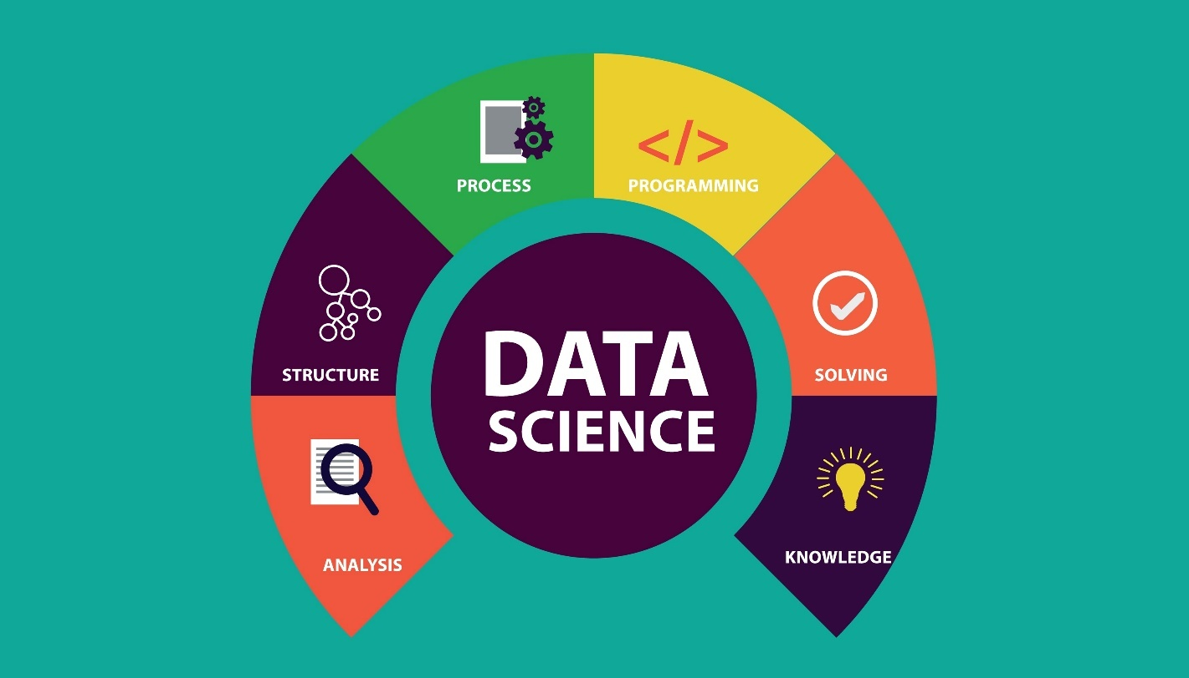
Shutterstock
- Muammoni aniqlashtirish (Clarifying the problem).
- Ma'lumot yig'ish (Data collection).
- Tahlil (Analysis).
- Andozalarni aniqlash (Pattern recognition).
- Hikoya so'zlash (Storytelling).
- Vizualizatsiya (Visualization).

3. Muvaffaqiyatli Data Scientistning 3 ta ustuni
Professor Murtaza Haider ta'kidlaganidek, sizda quyidagi xislatlar bo'lishi shart:
- Curiosity (Qiziquvchanlik): To'g'ri savollar berish va ma'lumotni chuqur o'rganish uchun.
- Argumentation (Asosli bahslashish): Ma'lumotlardan o'rganib, o'z topilmalaringizni ishonchli tushuntirib berish uchun.
- Judgment (To'g'ri baholash): Ishni to'g'ri yo'nalishda boshlash uchun.

4. Kimlar Data Scientist bo'la oladi?
Kompaniyalar faqat statistik olimlarni yoki kod yozuvchilarni qidirmayapti. Ularga "Versatile" (ko'p qirrali) insonlar kerak:
- Bitta sohani chuqur biladigan (Sizning holatingizda: Ta'lim va Harbiy boshqaruv).
- Dasturlashdan xabari bor (Sizda Laravel/PHP bor).
- Muloqot qila oladigan.
Mutaxassislar iqtisod, muhandislik, tibbiyot kabi turli sohalardan chiqishi mumkin.

5. Kelajak va Maslahat
- Sertifikat: Soha rivojlangani sari, kompaniyalar o'z xodimlaridan malaka isbotini, ya'ni sertifikatlarni talab qilishni boshlaydilar (Siz aynan shu yo'ldasiz).
- Mantiq va Algoritm: Texnologiya o'zgarsa ham, mantiqiy fikrlash va algoritmik yondashuv har doim kerak bo'ladi.
- Strategiya: O'z qiziqish sohangizni toping, shu soha uchun kerakli vositalarni o'rganing va haqiqiy muammolarni yechishga kirishing.

Defining Data Science Lesson Glossary
Welcome! This alphabetized glossary contains many of the terms in this course. These terms are important for you to recognize when working in the industry, participating in user groups, and participating in other certificate programs.
Term | Definition | Video where the term is introduced
Algorithms | A set of step-by-step instructions to solve a problem or complete a task. | What is Data Science?
Model | A representation of the relationships and patterns found in data to make predictions or analyze complex systems retaining essential elements needed for analysis. | What is Data Science?
Outliers | When a data point or points occur significantly outside of most of the other data in a data set, potentially indicating anomalies, errors, or unique phenomena that could impact statistical analysis or modeling. | What is Data Science?
Quantitative analysis | A systematic approach using mathematical and statistical analysis is used to interpret numerical data. | Many Paths to Data Science
Structured data | Data is organized and formatted into a predictable schema, usually related tables with rows and columns. | What is Data Science?
Unstructured data | Unorganized data that lacks a predefined data model or organization makes it harder to analyze using traditional methods. This data type often includes text, images, videos, and other content that doesn't fit neatly into rows and columns like structured data. | What is Data Science?

Mana, Data Science kursingizdagi ushbu darsga oid muhim atamalarning (Glossary) o‘zbek tilidagi izohli lug‘ati. Bu atamalar kelajakda sohada ishlaganingizda juda ko‘p uchraydi.
Atama (Inglizcha) | O'zbekcha nomi | Izoh va Tushuntirish
Algorithms | Algoritmlar | Muammoni hal qilish yoki biror vazifani bajarish uchun berilgan bosqichma-bosqich ko‘rsatmalar to‘plami. (Xuddi retsept kabi: 1-qadam, 2-qadam...).
Model | Model | Ma'lumotlar ichidagi bog‘liqlik va qonuniyatlarning nusxasi (aksi). Model kelajakni bashorat qilish yoki murakkab tizimlarni tahlil qilish uchun ishlatiladi.
Outliers | Ajralib qolgan qiymatlar (G'ayritabiiy og'ishlar) | Ma'lumotlar to‘plamidagi boshqa qiymatlardan keskin farq qiluvchi nuqta. Bu xatolik bo‘lishi ham mumkin, yoki noyob hodisa bo‘lishi ham mumkin (Masalan: hamma oyligi 5 mln so'm bo'lganda, bitta odamniki 100 mln so'm bo'lsa – bu outlier).
Quantitative analysis | Miqdoriy tahlil | Raqamli ma'lumotlarni tahlil qilish uchun matematika va statistika usullaridan foydalaniladigan tizimli yondashuv. (Asosan "Qancha?", "Nechta?" degan savollarga javob beradi).
Structured data | Strukturalashgan ma'lumotlar | Aniq bir qolipga solingan ma'lumotlar. Odatda jadvallar (qator va ustunlar) ko'rinishida bo'ladi (Masalan: Excel fayllari, SQL ma'lumotlar bazasi).
Unstructured data | Strukturalashmagan ma'lumotlar | Oldindan belgilangan qolipga ega bo'lmagan, tartibsiz ma'lumotlar. Bularni an'anaviy usullar bilan tahlil qilish qiyin. Misollar: matnlar, rasmlar, videolar, audio yozuvlar.
Siz uchun eslatma (Laravelchi sifatida):
- Structured Data – bu sizning MySQL yoki PostgreSQL bazangizdagi jadvallar.
- Unstructured Data – bu foydalanuvchilar yuklagan rasmlar yoki yozgan kommentariylari (matn).
- Outliers – tizimdagi "bug"lar yoki kutilmagan foydalanuvchi xatti-harakati bo'lishi mumkin.

[Music] I've built a recommendation engine before, as part of a large organization and worked through all types of engineers and accounted for different parts of the problem. It's one of the ones I'm most happy with because ultimately, I came up with a very simple solution that was easy to understand from all levels, from the executives to the engineers and developers. Ultimately, it was just as efficient as something really complex, and they could have spent a lot more time on. Back in the university, we have a problem that we wanted to predict algae blooms. This algae blooms could cause a rise in toxicity of the water and it could cause problems through the water treatment company. We couldn't like predict with our chemical engineering background. So we use artificial neural networks to predict when these blooms will reoccur.
So the water treatment companies could better handle this problem. In Toronto, the public transit is operated by Toronto Transit Commission. We call them TTC. It's one of the largest transit authorities in the region, in North America. And one day they contacted me and said, "We have a problem." And I said, "Okay, what's the problem?" They said, "Well, we have complaints data, and we would like to analyze it, and we need your help."
I said, "Fine I would be very happy to help." So I said, "How many complaints do you have?" They said, "A few." I said, "How many?" Maybe half a million. I said, "Well, let's start working with it." So I got the data and I started analyzing it.
So, basically, they have done a great job of keeping some data in tabular format that was unstructured data. And in that case, tabular data was when the complaint arrived, who received it, what was the type of the complaint, was it resolved, whose fault was it. And the unstructured part of it was the exchange of e-mails and faxes. So, imagine looking at how half a million exchanges of e-mails and trying to get some answers from it. So I started working with it. The first thing I wanted to know is why would people complain and is there a pattern or is there some days when there are more complaints than others? And I had looked at the data and I analyzed it in all different formats, and I couldn't find [what] the impetus for complaints being higher on a certain day and lower on others.
And it continued for maybe a month or so. And then, one day I was getting off the bus in Toronto, and I was still thinking about it. And I stepped out without looking on the ground, and I stepped into a puddle, puddle of water. And now, I was sort of ankle deep into water, and it was just one foot wet and the other dry. And I was extremely annoyed. And I was walking back and then it hit me, and I said, "Well, wait a second. Today it rained unexpectedly, and I wasn't prepared for it.
That's why I'm wet, and I wasn't looking for it." What if there was a relationship between extreme weather and the type of complaints TTC receives? So I went to the environment Canada's website, and I got data on rain and precipitation, wind and the light. And there, I found something very interesting. The 10 most excessive days for complaints. The 10 days where people complain the most were the days when the weather was bad. It was unexpected rain, an extreme drop in temperature, too much snow, very windy day.
So I went back to the TTC's executives and I said, "I've got good news and bad news." And the good news is, I know why people would complain excessively on certain days. I know the reason for it. The bad news is, there's nothing you can do about it. [Music]

Bu videotranskriptda Data Science qanday qilib real hayotiy muammolarni hal qilishi haqida uchta qiziqarli hikoya (keys) keltirilgan. Spikerlar o‘z tajribalaridan kelib chiqib, ma'lumotlar tahlili qanchalik kuchli qurol ekanligini ko‘rsatib berishadi.
Quyida har bir hikoyani va undan olinadigan saboqni tushuntirib beraman:

1-hikoya: Oddiylikning kuchi (Tavsiya tizimi)
Bir muhandis katta tashkilot uchun tavsiya qilish tizimini (recommendation engine – xuddi YouTube yoki Netflix sizga video tavsiya qilgani kabi) yaratgan.
- Muammo: Murakkab tizim qurish mumkin edi.
- Yechim: U juda oddiy yechim o'ylab topdi. Bu yechimni oddiy dasturchidan tortib rahbarlargacha (executives) hamma tushuna olardi.
- Natija: Bu oddiy yechim juda murakkab tizimlar kabi samarali ishladi.
- Xulosa: Har doim ham eng qiyin yo'l eng to'g'ri yo'l emas. Soddalik va tushunarlilik – Data Science'da katta yutuq.

2-hikoya: Suv o'tlari (Algae Blooms) va Neyron tarmoqlar
Universitetda talabalar suvning zaharlanishiga olib keladigan zararli suv o'tlari (algae) qachon paydo bo'lishini oldindan bilishmoqchi bo'lishdi.
- Muammo: Ularning kimyoviy muhandislik bilimlari buni bashorat qilishga yetmadi.
- Yechim: Ular Sun'iy Neyron Tarmoqlaridan (Artificial Neural Networks - AI turi) foydalanishdi.
- Natija: Suv tozalash kompaniyalari muammoni oldindan bilib, unga tayyorgarlik ko'ra oladigan bo'lishdi.
- Xulosa: An'anaviy fanlar (kimyo, fizika) ojiz qolganda, ma'lumotlar va AI yordamga keladi.

3-hikoya: Avtobus va Yomg'ir (TTC Complaints) – Eng qiziq qismi
Toronto jamoat transporti (TTC) 500,000 ga yaqin shikoyatlarni tahlil qilishni so'raydi.
- Ma'lumotlar:
  - Strukturalashgan: Shikoyat vaqti, turi, hal qilinganligi (jadval shaklida).
  - Strukturalashmagan: Elektron pochta va fakslar (matn shaklida).
- Jarayon: Data Scientist ma'lumotlarni tahlil qiladi, lekin nega ba'zi kunlari shikoyat ko'payib ketishini tushuna olmaydi. Hech qanday qonuniyat (pattern) topilmaydi.
- Burilish nuqtasi: Bir kuni u avtobusdan tushayotib, ko'lmakka (suvga) tushib ketadi va oyog'i ho'l bo'lib, qattiq jahli chiqadi. Shunda kallasiga fikr keladi: "Balki ob-havo yomon bo'lsa, odamlar ko'proq shikoyat qilar?"
- Tahlil: U ob-havo ma'lumotlarini (yomg'ir, qor, shamol) yuklab oladi va shikoyatlar bilan solishtiradi.
- Natija: Eng ko'p shikoyat tushgan 10 ta kun – ob-havo eng yomon bo'lgan kunlar ekan! Odamlar asabiylashgani uchun arzimas narsaga ham shikoyat qilaverishgan.
- Xulosa:
  - Tashqi ma'lumotlar (External Data): Ba'zan javob sizning ma'lumotlar bazangizda emas, tashqarida (masalan, ob-havo ma'lumotida) bo'ladi.
  - Inson omili: Data Scientist faqat kod yozmaydi, u hayotni kuzatishi kerak. Ko'lmakka tushish muammoning yechimini topishga yordam berdi.

Music I'm Norman White, I'm a Clinical Faculty Member in the IOMS Department, Information, Operations and Management Science Department here at Stern. I've been here for a long time (laughs), since I got out of college, pretty much. I'm sort of a techy, geeky kind of person. I really like to play with technology in my spare time. I'm currently Faculty Director of the Stern Center for Research Computing, in which we have a private cloud that runs lots of different kinds of systems. Many of our faculty or PhD students who need specialized hardware and software will come to us, we'll spin up a machine for them, configure it, I'll help them and advise on them. A lot of the data scientists, or virtually all the data scientists at Stern use our facilities.
And their PhD students use them a lot. (music) I have an undergraduate degree in Applied Physics and while I was an undergrad I took a number of economics courses, so I ended up deciding to go to business school, but I had, this was in the early days of computers (laughs) and I had gotten interested in computers. I came to Stern, which was then NYU Business School downtown and they had a little computer center, and I decided that I was gonna learn two things while I was there. One, I was gonna learn how to program. I had taken one programming course in college. And I was gonna learn how to touch type. I never did learn how to touch type (laughs). Or maybe I did but I've forgotten now, and back to two finger pecking.
But I became a self taught programmer, and then I took a number of courses at IBM because I eventually became the director of the computer center, while I was getting my PhD in Economics and Statistics at Stern. In 1973, the school formed a department called Computer Applications and Information Systems and I was one of the first faculty members in the department and I've been here ever since (laughs). (music) My typical Monday is, I usually get in around 11 o'clock and I do my email at home first, but I come in and I have two classes on Monday. I have a class on design and development of web based systems at six o'clock. Two o'clock, I have a dealing with data class. The class is based on Python notebooks, so we start with the basics of Unix and Linux, just to get the students used to that. We move onto some Python, some regular expressions, a lot of relational databases, some Python Pandas, which is sort of like R for Python, lets you do mathematical and statistical calculations in Python. And then I end up with big data, for which, as you probably know, I'm an evangelist.
The students I have, weekly homeworks. I put them in teams and they have to do a big project at the end of the term, and they do some really cool things. (music) Yes, in fact, the whole course is taught using Jupyter notebooks. Every student has their own virtual machine on Amazon Web Services, so we pre configure all the machines and they get a standard image that has all of the materials for the course either loaded on it or in a Jupyter notebook, there are the commands to download it or update the server with the right software. So everybody is in the same environment, it doesn't matter what kind of, whether they have a Mac or a Windows machine or how old it is, everybody can do everything in the class. (upbeat music)

Bu matn NYU Stern biznes maktabi professori Norman White bilan bo‘lgan suhbatdir. U o‘zining faoliyati, Data Science sohasiga qanday kirib kelgani va talabalarga qanday dars berishi haqida gapirib beradi.
Siz uchun qiziq bo'lgan asosiy nuqtalar (ayniqsa, web-dasturchi sifatidagi tajribangizni hisobga olganda):

1. Web Dasturlash va Data Science birlashuvi
Norman White nafaqat ma'lumotlar bilan, balki "Web Based Systems" (Webga asoslangan tizimlar) bo'yicha ham dars beradi.
- Sizga aloqasi: Siz Laravelda (Web) ishlayapsiz. Professorning aytishicha, Data Science faqat quruq hisob-kitob emas, uni web-tizimlar orqali ishlata olish muhim.

2. O'qitish metodikasi va Texnologiyalar
Professor o'zining "Dealing with Data" (Ma'lumotlar bilan ishlash) kursida quyidagi texnologiyalarni o'rgatadi:
- Unix/Linux: Asosiy buyruqlar (Siz OSPanelda ishlagansiz, lekin Linux serverlarda ishlash uchun bu juda muhim).
- Python & Pandas: U Pandas kutubxonasini "Python uchun R" deb ataydi. Bu ma'lumotlarni xuddi Exceldagi kabi, lekin kod orqali tahlil qilish imkonini beradi.
- Relational Databases (SQL): Ma'lumotlar bazasi bilan ishlash (Siz buni Laravelda yaxshi bilasiz).
- Big Data: Katta hajmdagi ma'lumotlar.

3. Dars jarayoni va Bulutli texnologiyalar (AWS)
Bu qism juda qiziq. Talabalar turli xil kompyuter (Mac, Windows) ishlatgani uchun muammo chiqmasligi maqsadida, professor Amazon Web Services (AWS) dan foydalanadi.
- Har bir talabaga bitta virtual mashina (server) ajratiladi.
- Hamma kerakli dasturlar oldindan o'rnatilgan bo'ladi.
- Talabalar Jupyter Notebooks orqali kod yozishadi va natijani ko'rishadi.

4. Shaxsiy hikoyasi (Motivatsiya)
- U aslida Fizika bo'yicha o'qigan.
- Dasturlashni mustaqil (self-taught) o'rgangan.
- U "Men dasturlashni va klaviaturaga qaramasdan yozishni (touch type) o'rganmoqchi edim. Dasturlashni o'rgandim, lekin yozishni hali ham ikki barmog'imda qilaman" deb hazillashadi.
- 1973-yilda birinchilardan bo'lib "Kompyuter ilovalari" kafedrasini tashkil qilgan.

As a data professional, you will be working with a variety of data file types, and formats. It is important to understand the underlying structure of file formats along with their benefits and limitations. This understanding will support you to make the right decisions on the formats best suited for your data and performance needs. Some of the standard file formats that we will cover in this video include: Delimited text file formats, Microsoft Excel Open XML Spreadsheet, or XLSX Extensible Markup Language, or XML, Portable Document Format, or PDF, JavaScript Object Notation, or JSON, Delimited text files are text files used to store data as text in which each line, or row, has values separated by a delimiter; where a delimiter is a sequence of one or more characters for specifying the boundary between independent entities or values. Any character can be used to separate the values, but most common delimiters are the comma, tab, colon, vertical bar, and space. Comma-separated values (or CSVs) and tab-separated values (or TSVs) are the most commonly used file types in this category. In CSVs, the delimiter is a comma while in TSVs, the delimiter is a tab.
When literal commas are present in text data and therefore cannot be used as delimiters, TSVs serve as an alternative to CSV format. Tab stops are infrequent in running text. Each row, or horizontal line, in the text file has a set of values separated by the delimiter, and represents a record. The first row works as a column header, where each column can have a different type of data. For example, a column can be of date type, while another can be a string or integer type data. Delimited files allow field values of any length and are considered a standard format for providing straightforward information schema. They can be processed by almost all existing applications.
Delimiters also represent one of various means to specify boundaries in a data stream. Microsoft Excel Open XML Spreadsheet, or XLSX, is a Microsoft Excel Open XML file format that falls under the spreadsheet file format. It is an XML-based file format created by Microsoft. In an .XLSX, also known as a workbook, there can be multiple worksheets. And each worksheet is organized into rows and columns, at the intersection of which is the cell. Each cell contains data.
XLSX uses the open file format, which means it is generally accessible to most other applications. It can use and save all functions available in Excel and is also known to be one of the more secure file formats as it cannot save malicious code. Extensible Markup Language, or XML, is a markup language with set rules for encoding data. The XML file format is both readable by humans and machines. It is a self-descriptive language designed for sending information over the internet. XML is similar to HTML in some respects, but also has differences. For example, an .XML does not use predefined tags like .HTML does.
XML is platform independent and programming language independent and therefore simplifies data sharing between various systems. Portable Document Format, or PDF, is a file format developed by Adobe to present documents independent of application software, hardware, and operating systems, which means it can be viewed the same way on any device. This format is frequently used in legal and financial documents and can also be used to fill in data such as for forms. JavaScript Object Notation, or JSON, is a text-based open standard designed for transmitting structured data over the web. The file format is a language-independent data format that can be read in any programming language. JSON is easy to use, is compatible with a wide range of browsers, and is considered as one of the best tools for sharing data of any size and type, even audio and video. That is one reason, many APIs and Web Services return data as JSON.
In this video, we looked at some popular file and data formats. In the next video, we will learn about the different sources of data.

Bu matn Data Science mutaxassisi ishlashi kerak bo‘lgan asosiy fayl formatlari va turlari haqida.
Siz Laravel (Web) dasturchisi sifatida bu formatlarning ko‘pini allaqachon bilasiz, lekin Data Science’da ular ma'lumotlarni saqlash va tahlil qilish manbai sifatida qaraladi.
Quyida videoda aytilgan 5 ta asosiy formatni tushuntirib beraman:

1. Delimited Text Files (Ajratilgan matnli fayllar)
Bular oddiy matn fayllari bo‘lib, undagi ma'lumotlar maxsus belgi (delimiter) bilan ajratilgan bo‘ladi.
- Delimiter nima? Ma'lumotlarni bir-biridan ajratib turuvchi belgi (masalan: virgul, tab, ikki nuqta, vertikal chiziq).
- CSV (Comma-Separated Values): Ma'lumotlar virgul (,) bilan ajratiladi. Eng keng tarqalgan format.
- TSV (Tab-Separated Values): Ma'lumotlar Tab (klaviaturadagi Tab tugmasi) orqali ajratiladi.
  - Qachon ishlatiladi? Agar ma'lumotning o‘zida virgul qatnashgan bo‘lsa (masalan, matn ichida), CSV xato ishlashi mumkin. Shunda TSV ishlatiladi.
- Tuzilishi: Har bir qator – bitta yozuv (record). Birinchi qator odatda sarlavha (header) bo‘ladi.

2. Microsoft Excel Open XML (XLSX)
Bu Microsoft Excelning zamonaviy fayl formati.
- Tuzilishi: Workbook (Kitob) -> Worksheets (Varaqlar) -> Rows/Columns (Qator/Ustun) -> Cells (Katakchalar).
- Xavfsizlik: XLSX formati makroslarni (dastur kodlarini) o‘zida saqlay olmaydi, shuning uchun u viruslardan xoli, xavfsizroq hisoblanadi.
- XML asosida: Bu format aslida XML texnologiyasiga asoslangan bo‘lib, ko‘plab dasturlar uni ocha oladi.

3. XML (Extensible Markup Language)
HTMLga o‘xshash, lekin maqsadi boshqa.
- Farqi: HTML ma'lumotni ko‘rsatish (dizayn) uchun, XML esa ma'lumotni tashish va saqlash uchun ishlatiladi.
- Teglar (Tags): HTMLda teglar oldindan belgilangan (<b>, <div>), XMLda esa teglarni o‘zingiz o‘ylab topasiz (masalan: <talaba>, <baho>, <kurs>).
- O‘qilishi: Ham odam, ham kompyuter bemalol o‘qiy oladi. Tizimlararo ma'lumot almashishda (platform independent) juda qulay.

4. PDF (Portable Document Format)
Adobe tomonidan yaratilgan format.
- Asosiy xususiyati: Qaysi qurilmada (telefon, noutbuk, planshet) ochishdan qat'i nazar, hujjat ko‘rinishi o‘zgarmaydi.
- Ishlatilishi: Yuridik hujjatlar, hisobotlar va moliyaviy qog‘ozlar uchun standart. Data Science'da PDFdan ma'lumot sug‘urib olish (parsing) biroz qiyinroq, lekin muhim manba.

5. JSON (JavaScript Object Notation)
Sizga eng tanish format!
- Tavsifi: Web orqali ma'lumot uzatishning "qiroli". API va Web xizmatlar (Web Services) asosan JSON qaytaradi.
- Afzalligi: Yengil, o‘qish oson va istalgan dasturlash tilida (Python, PHP, JS) bemalol ishlaydi.
- Tuzilishi: Kalit-qiymat (Key-Value) ko‘rinishida bo‘ladi.
Xulosa:
Data Scientist sifatida sizga mijoz ma'lumotni Excelda, loglarni CSVda, API javoblarini JSONda berishi mumkin. Sizning vazifangiz – bu formatlarning har birini ochib, ichidan kerakli "oltin"ni (insight) qazib olishdir.
Keyingi qadam: Videoning oxirida aytilishicha, keyingi darsda ma'lumot manbalari (Data Sources) haqida gaplashasiz. Davom etamizmi?

[Music] I really enjoy regression. I'd say regression was maybe one of the first concepts that I, that really helped me understand data so I enjoy regression. I really like data visualization. I think it's a key element for people to get across their message to people that don't understand that well what data science is. Artificial neural networks. I'm really passionate about neural networks because we have a lot to learn with nature so when we are trying to mimic our, our brain I think that we can do some applications with this behavior with this biological behavior in algorithms. Data visualization with R. I love to do this.
Nearest neighbor. It's the simplest but it just gets the best results so many more times than some overblown, overworked algorithm that's just as likely to overfit as it is to make a good fit. So structured data is more like tabular data things that you’re familiar with in Microsoft Excel format. You've got rows and columns and that's called structured data. Unstructured data is basically data that is coming from mostly from web where it's not tabular. It is not, it's not in rows and columns. It's text.
It's sometimes it's video and audio, so you would have to deploy more sophisticated algorithms to extract data. And in fact, a lot of times we take unstructured data and spend a great deal of time and effort to get some structure out of it and then analyze it. So if you have something which fits nicely into tables and columns and rows, go ahead. That's your structured data. But if you see if it's a weblog or if you're trying to get information out of webpages and you've got a gazillion web pages, that's unstructured data that would require a little bit more effort to get information out of it. There are thousands of books written on regression and millions of lectures delivered on regression. And I always feel that they don’t do a good job of explaining regression because they get into data and models and statistical distributions.
Let's forget about it. Let me explain regression in the simplest possible terms. If you have ever taken a cab ride, a taxi ride, you understand regression. Here is how it works. The moment you sit in a cab ride, in a cab, you see that there's a fixed amount there. It says $2.50. You, rather the cab, moves or you get off.
This is what you owe to the driver the moment you step into a cab. That's a constant. You have to pay that amount if you have stepped into a cab. Then as it starts moving for every meter or hundred meters the fare increases by certain amount. So there's a... there's a fraction, there's a relationship between distance and the amount you would pay above and beyond that constant. And if you're not moving and you're stuck in traffic, then every additional minute you have to pay more. So as the minutes increase, your fare increases.
As the distance increases, your fare increases. And while all this is happening you've already paid a base fare which is the constant. This is what regression is. Regression tells you what the base fare is and what is the relationship between time and the fare you have paid, and the distance you have traveled and the fare you've paid. Because in the absence of knowing those relationships, and just knowing how much people traveled for and how much they paid, regression allows you to compute that constant that you didn't know. That it was $2.50, and it would compute the relationship between the fare and and the distance and the fare and the time. That is regression.

Bu videotranskriptda Data Science bo'yicha uchta muhim mavzu haqida so'z boradi: mutaxassislarning sevimli usullari, ma'lumot turlari va Regressiya tushunchasining ajoyib, sodda tushuntirilishi.
Quyida ularni batafsil ko'rib chiqamiz:

1. Mutaxassislarning sevimli vositalari
Turli Data Scientistlar o'zlari yaxshi ko'radigan usullarni sanab o'tishdi:
- Regressiya (Regression): Ma'lumotni tushunishga yordam beradigan eng birinchi va asosiy vosita.
- Ma'lumotlar vizualizatsiyasi (Data Visualization): Data Science nimaligini tushunmaydigan odamlarga xabar yetkazishning eng yaxshi yo'li (R tili orqali chizishni yoqtirishar ekan).
- Sun'iy Neyron Tarmoqlari (Artificial Neural Networks): Tabiatdan va inson miyasidan andoza olgani uchun juda qiziqarli.
- Eng yaqin qo'shni (Nearest Neighbor): Bu juda oddiy algoritm, lekin ko'pincha o'ta murakkab va "haddan tashqari ishlangan" (overfitted) algoritmlardan ko'ra yaxshiroq va aniqroq natija beradi.

2. Strukturalashgan va Strukturalashmagan ma'lumotlar
Bu farqni siz ma'lumotlar bazasi (SQL) bilan ishlagan odam sifatida yaxshi tushunasiz:
- Strukturalashgan (Structured):
  - Bular Microsoft Excelga o'xshash ma'lumotlar.
  - Aniq qatorlar (rows) va ustunlar (columns) bor.
  - Tahlil qilish oson.
- Strukturalashmagan (Unstructured):
  - Asosan Internetdan olinadigan ma'lumotlar.
  - Matnlar, videolar, audiolar, web-sahifalar.
  - Ular jadvalga sig'maydi. Ulardan ma'lumot ajratib olish uchun murakkab algoritmlar va ko'proq vaqt talab etiladi.

3. Regressiya: Taksi (Cab Ride) misolida
Bu videoning eng muhim qismi. Kitoblarda Regressiyani juda qiyin matematik formulalar bilan tushuntirishadi, lekin spiker buni Taksi misolida tushuntirib berdi:
Tasavvur qiling, taksiga o'tirdingiz:
- O'zgarmas qiymat (Constant / Intercept): Taksiga o'tirishingiz bilan hisoblagichda $2.50 yozuvini ko'rasiz. Mashina hali yurgani yo'q, lekin siz shu pulni to'lashingiz shart. Bu – "Baza narxi".
- O'zgaruvchilar (Variables):
  - Mashina yura boshlagach, har bir kilometr uchun narx oshib boradi.
  - Agar probkada tursangiz, o'tgan vaqt (minut) uchun ham narx oshadi.
Regressiya nima qiladi?
Agar sizda faqat yakuniy narxlar va bosib o'tilgan masofa bo'lsa, Regressiya orqaga qaytib, quyidagi yashirin qonuniyatlarni topib beradi:
- "Boshlang'ich narx (o'tirish haqi) qancha edi?" (Constant).
- "Har bir kilometrga qancha pul qo'shildi?" (Coefficient).
Demak, Regressiya – bu masofa va vaqtning yakuniy narxga qanday ta'sir qilishini (bog'liqligini) hisoblab beruvchi usuldir.

Course Text Book: 'Getting Started with Data Science' Publisher: IBM Press; 1 edition (Dec 13 2015) Print.
Author: Murtaza Haider
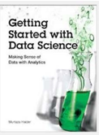
Prescribed Reading: Chapter 1 Pg. 12-15

What Makes Someone a Data Scientist?
Now that you know what is in the book, it is time to put down some definitions. Despite their ubiquitous use, consensus evades the notions of Big data and Data Science. The question, Who is a data scientist? is very much alive and being contested by individuals, some of whom are merely interested in protecting their discipline or academic turfs. In this section, I attempt to address these controversies and explain Why a narrowly construed definition of either Big data or Data science will result in excluding hundreds of thousands of individuals who have recently turned to the emerging field.
Everybody loves a data scientist, wrote Simon Rogers (2012) in the Guardian. Mr. Rogers also traced the newfound love for number crunching to a quote by Google's Hal Varian, who declared that the sexy job in the next ten years will be statisticians.
Whereas Hal Varian named statisticians sexy, it is widely believed that what he really meant were data
scientists. This raises several important questions:
- What is data science?
- How does it differ from statistics?
- What makes someone a data scientist?
In the times of big data, a question as simple as, What is data science? can result in many answers. In some cases, the diversity of opinion on these answers borders on hostility.
I define a data scientist as someone who finds solutions to problems by analyzing Big or small data using appropriate tools and then tells stories to communicate her findings to the relevant stakeholders. I do not use the data size as a restrictive clause. A data below a certain arbitrary threshold does not make one less of a data scientist. Nor is my definition of a data scientist restricted to particular analytic tools, such as machine learning. As long as one has a curious mind, fluency in analytics, and the ability to communicate the findings, I consider the person a data scientist.
I define data science as something that data scientists do. Years ago, as an engineering student at the University of Toronto, I was stuck With the question: What is engineering? I wrote my master's thesis on forecasting housing prices and my doctoral dissertation on forecasting homebuilders' choices related to What they build, when they build, and where they build new housing. In the civil engineering department, Others were working on designing buildings, bridges, tunnels, and worrying about the stability of slopes. My work, and that of my supervisor, was not your traditional garden-variety engineering. Obviously, I was repeatedly asked by others whether my research was indeed engineering.
When I shared these concerns with my doctoral supervisor, Professor Eric Miller, he had a laugh. Dr Miller spent a lifetime researching urban land use and transportation and had earlier earned a doctorate from MIT. “Engineering is what engineers do,” he responded. Over the next 17 years, I realized the wisdom in his statement. You first become an engineer by obtaining a degree and then registering with the local professional body that regulates the engineering profession. Now you are an engineer. You can dig tunnels; write software codes; design components of an iPhone or a supersonic jet. You are an engineer. And when you are leading the global response to a financial crisis in your role as the chief economist of the International Monetary Fund (IMF), as Dr Raghuram Rajan did, you are an engineer.
Professor Raghuram Rajan did his first degree in electrical engineering from the Indian Institute of Technology. He pursued economics in graduate studies, later became a professor at a prestigious university, and eventually landed at the IMF. He is currently serving as the 23rd Governor of the Reserve Bank of India. Could someone argue that his intellectual prowess is rooted only in his training as an economist and that the fundamentals he learned as an engineering student played no role in developing his problem-solving abilities?
Professor Rajan is an engineer. So are Xi Jinping, the President of the People's Republic of China, and Alexis Tsipras, the Greek Prime Minister who is forcing the world to rethink the fundamentals of global economics. They might not be designing new circuitry, distillation equipment, or bridges, but they are helping build better societies and economies and there can be no better definition of engineering and engineers—that is, individuals dedicated to building better economies and societies.
So briefly, I would argue that data science is what data scientists do.
Others have many different definitions. In September 2015, a co-panelist at a meetup organized by BigDataUniversity.com in Toronto confined data science to machine learning. There you have it. If you are not using the black boxes that makeup machine learning, as per some experts in the field, you are not a data scientist. Even if you were to discover the cure to a disease threatening the lives of millions, turf-protecting colleagues will exclude you from the data science club.
Dr Vincent Granville (2014), an author on data science, offers certain thresholds to meet to be a data scientist. On pages 8 and 9 in Developing Analytic talent, Dr Granville describes the new data science professor as a non-tenured instructor at a non-traditional university, who publishes research results in online blogs, does not waste time writing grants, works from home, and earns more money than the traditional tenured professors. Suffice it to say that the thriving academic community of data scientists might disagree with Dr Granville.
Dr Granville uses restrictions on data size and methods to define what data science is. He defines a data scientist as one who can easily process a So-million-row data set in a couple of hours, and who distrusts (statistical) models. He distinguishes data science from statistics. Yet he lists algebra, calculus, and training in probability and statistics as necessary background to understand data science (page 4).
Some believe that big data is merely about crossing a certain threshold on data size or the number of observations, or is about the use of a particular tool, such as Hadoop. Such arbitrary thresholds on data size are problematic because, with innovation, even regular computers and off-the-shelf software have begun to manipulate very large data sets. Stata, a commonly used software by data scientists and statisticians, announced that one could now process between 2 billion to 24.4 billion rows using its desktop solutions. If Hadoop is the password to the big data club, Stata's ability to process 24.4 billion rows, under certain limitations, has just gatecrashed that big data party.
It is important to realize that one who tries to set arbitrary thresholds to exclude others is likely to run into inconsistencies. The goal should be to define data science in a more exclusive, discipline- and platform-independent, size-free context where data-centric problem solving and the ability to weave strong narratives take center stage.
Given the controversy, I would rather consult others to see how they describe a data scientist. Why don't we again consult the Chief Data Scientist of the United States? Recall Dr Patil told the Guardian newspaper in 2012 that a data scientist is that unique blend of skills that can both unlock the insights of data and tell a fantastic story via the data. What is admirable about Dr Patil's definition is that it is inclusive of individuals of various academic backgrounds and training, and does not restrict the definition of a data scientist to a particular tool or subject it to a certain arbitrary minimum threshold of data size.
The other key ingredient for a successful data scientist is a behavioral trait: curiosity. A data scientist has to be one with a very curious mind, willing to spend significant time and effort to explore her hunches. In journalism, the editors call it having the nose for news. Not all reporters know where the news lies. Only those Who have the nose for news get the Story. Curiosity is equally important for data scientists as it is for journalists.
Rachel Schutt is the Chief Data Scientist at News Corp. She teaches a data science course at Columbia University. She is also the author of an excellent book, Doing Data Science. In an interview With the New York Times, Dr Schutt defined a data scientist as someone who is a part computer scientist, part software engineer, and part statistician (Miller, 2013). But that's the definition of an average data scientist. "The best", she contended, "tend to be really curious people, thinkers who ask good questions and are O.K. dealing with unstructured situations and trying to find structure in them."


Bu matn Murtaza Haiderning "Getting Started with Data Science" kitobidan (1-bob, 12-15 betlar) olingan parcha bo'lib, u "Data Scientist (Ma'lumotshunos) o'zi kim?" degan savolga javob izlaydi.
Muallif bu yerda qolipga tushib qolgan "tor" ta'riflarga qarshi chiqadi va kengroq, mazmunliroq tushunchani ilgari suradi. Matnning asosiy g'oyalarini quyidagicha tushuntirish mumkin:

1. Data Scientist kim? (Muallifning ta'rifi)
Ko'pchilik Data Scientistni faqat "Katta ma'lumotlar" (Big Data) yoki faqat "Machine Learning" bilan ishlaydigan odam deb o'ylaydi. Muallif bunga qo'shilmaydi.
Uning ta'rifi quyidagicha:
Data Scientist – bu katta yoki kichik ma'lumotlarni tahlil qilish orqali muammolarga yechim topadigan va o'z topilmalarini manfaatdor tomonlarga "hikoya" (storytelling) qilib tushuntirib beradigan shaxsdir.
- Ma'lumot hajmi muhim emas: Siz 50 million qatorli ma'lumot bilan ishlaysizmi yoki kichik excel jadval bilanmi – agar muammoni hal qilsangiz, siz Data Scientistsiz.
- Asbob muhim emas: Hadoop yoki murakkab "qora quti" (black box) modellarni ishlatish shart emas.

2. "Muhandislik" o'xshatishi (Engineering Analogy)
Muallif o'zining talabalik davrini eslaydi. U professori Eric Millerdan "Muhandislik o'zi nima?" deb so'raganda, ustozi shunday javob bergan:
"Muhandislik – bu muhandislar qiladigan ishdir."
Bu oddiy gapning tagida chuqur ma'no bor. Masalan, Xalqaro Valyuta Jamg'armasi rahbari bo'lgan iqtisodchi yoki Xitoy prezidenti Xi Jinping aslida muhandislik diplomiga ega. Ular ko'prig qurishmasa ham, ular jamiyat va iqtisodiyotni "qurmoqdalar".
Xuddi shu kabi, Data Science – bu Data Scientistlar qiladigan ishdir.

3. Noto'g'ri qarashlar va Cheklovlar
Muallif boshqa ekspertlarning (masalan, Dr. Vincent Granville) fikrlarini tanqid qiladi. Ba'zilar aytishicha, agar siz ma'lum bir dasturni ishlatmasangiz yoki millionlab qator kod yozmasangiz, siz soha vakili emassiz.
- Texnologiya o'zgaruvchan: Oldin faqat "Hadoop" qila oladigan ishlarni hozir oddiy kompyuterda "Stata" kabi dasturlar ham qila oladi (24 milliard qatorgacha!).
- Xulosa: Asbobga yoki ma'lumot hajmiga qarab "Siz Data Scientist emassiz" deyish noto'g'ri.

4. Eng muhim xislat: Qiziquvchanlik (Curiosity)

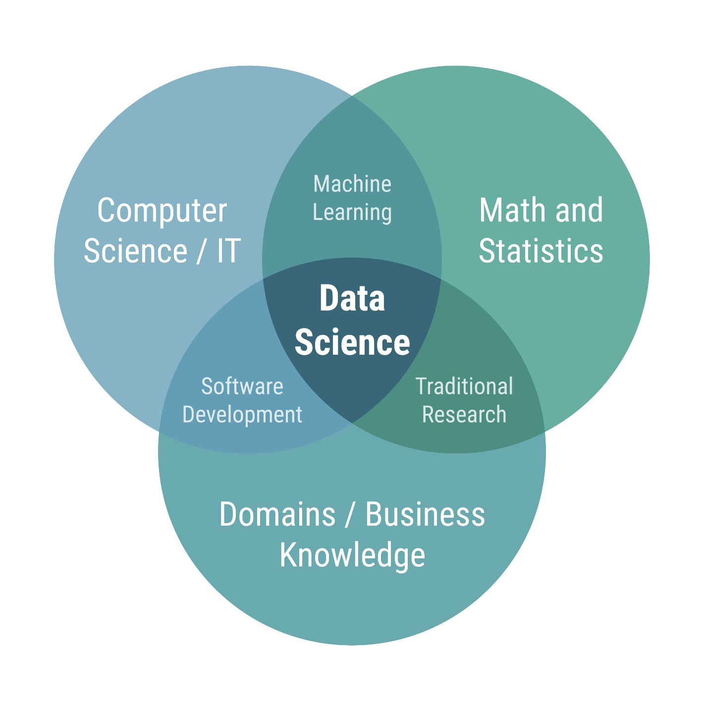
AQShning Bosh Data Scientisti DJ Patil va News Corp vakili Rachel Schuttning fikriga ko'ra, eng yaxshi mutaxassislar quyidagi xislatlarga ega:
- Turli soha egalari: Ular kompyuterchi, statistik yoki fizik bo'lishi mumkin.
- Hikoyachilar: Ma'lumotni tushunarli qilib yetkazib beradilar.
- Qiziquvchanlik (Curiosity): Bu eng muhimi. Xuddi jurnalistlarda "yangilikni hidini sezish" qobiliyati bo'lganidek, Data Scientistda ma'lumot ichidan qiziq narsani topa olish istagi bo'lishi kerak.
Siz uchun xulosa:
Siz Laravel dasturchisi va o'qituvchisiz. Muallifning fikricha, siz Data Scientist bo'lishingiz uchun darrov murakkab Machine Learning modellarini bilishingiz shart emas.
Asosiysi:
- Muammoni aniqlash.
- Ma'lumot yordamida unga yechim topish (PHPda bo'ladimi, Python yoki Exceldami – farqi yo'q).
- Topgan natijangizni o'quvchilaringizga yoki rahbaringizga tushunarli qilib aytib berish.

Welcome to a realm where data isn't just numbers. It's the gateway to innovation, discovery, and the endless possibilities that lie ahead. To understand the heart and soul of a data scientist world, let's review what data scientists do as discussed in the readings and videos from this lesson. Data scientist investigate and find explanations for many problems. For example, Dr. Murtaza Haider found an explanation for why half a million customers complained about public transit in Toronto. After much investigation, he found a relationship between unexpected bad weather events and the number of complaints on that particular day.
Data scientist may tackle environmental challenges such as predicting algae blooms to prevent water toxicity. By harnessing data in the prowess of artificial neural networks, data scientist can help water treatment companies safeguard the ecosystem. Norman White, a clinical faculty member at the Stern School of Business, also discussed the journey that led him to build a recommendation engine that simplified intricate problems across departments. This underscores the essence of data science, solving real world issues with innovative solutions. Education serves as a cornerstone, equipping future data scientists with essential skills. Dr. White's classroom comes alive with Python notebooks, revealing the secrets of Unix, Linux, relational databases, and powerful tools like Pandas.
Dr. Vincent Granville, an author on data science, lists algebra, calculus, and training, and probability and statistics as necessary educational backgrounds to be a data scientist. He distinguishes between a statistician and a data scientist. A data scientist uses statistics, but is not only a statistician. However, data scientists do use a lot of statistical models, such as statistical regression. Regression shows the probable relationship between two variables, such as the distance you drive and the amount of gas you use. Data scientists also utilize machine learning algorithms such as nearest neighbor to process what much of the media refers to as big data.
The term should be used with caution. What was once considered big data is continually reshaped by innovation. Tools like Hadoop and software advancements have shattered traditional limits, ushering in a new era of possibilities. Neither does Dr. Patel restrict data scientists to dealing with datasets of arbitrary size, nor does he restrict them to using particular tools. His definition includes individuals of various academic backgrounds and training. A data scientist not only unlocks the insights within a dataset, but conveys a compelling narrative to stakeholders.
It's this blend of technical acumen and communication finesse that sets them apart. The the data that data scientists use comes from a wide variety of sources. Sometimes video, sometimes audio, and often unformatted text. Text-based data can also be structured, such as in tables with rows and columns, or unstructured like emails or logs. The data they work with comes in a wide variety of formats, such as delimited text files, spreadsheets, XML, PDFs, and Javascript Object Notation, or JSON. What makes a data scientist truly exceptional? The answer, according to Rachel Schutt, chief data scientist at News Corp, lies in curiosity.
A successful data scientist is a blend of computer scientist, software engineer, and statistician. Their ability to transform unstructured solutions into structured insights defines their prowess. As we reflect on the insights from a day in the life of a data scientist, we realize that data science isn't just a profession. It's a journey of exploration, innovation, and story telling. The world of data is vast and the data scientist, armed with skills, curiosity and determination, navigates it to unravel the extraordinary.

Bu matn siz o‘rgangan ushbu modulning yakuniy xulosasi hisoblanadi. Unda Data Scientist kimligi, u nimalar qilishi va qanday vositalardan foydalanishi haqidagi barcha muhim ma'lumotlar jamlangan.
Quyida videoda aytilgan asosiy fikrlarni tizimlashtirib beraman:

1. Data Scientist nima qiladi? (Real misollar)
Data Science faqat raqamlar emas, bu innovatsiya va muammolarni yechishdir.
- Doktor Murtaza Haider: Nega Toronto jamoat transportida shikoyatlar ko‘payib ketganini o‘rgandi va buni kutilmagan yomon ob-havo bilan bog‘ladi.
- Ekologiya: Sun'iy neyron tarmoqlari yordamida suv o‘tlarining ko‘payishini (algae blooms) va suvning zaharlanishini oldindan aniqlash mumkin.
- Norman White: Murakkab muammolarni hal qilish uchun oddiy va tushunarli tavsiya tizimini (recommendation engine) yaratdi.

2. Ta'lim va Ko'nikmalar
Data Scientist bo‘lish uchun qanday bilimlar kerak?
- Texnik vositalar: Norman White o‘z darslarida Python, Linux, Unix, SQL va Pandasni o‘rgatadi. (Eslatma: Siz Linux va SQLni bilasiz, demak poydevoringiz bor).
- Matematik bilimlar: Doktor Vincent Granville fikricha, Algebra, Analiz (Calculus), Ehtimollar nazariyasi va Statistika zarur.
- Regressiya (Regression): Bu statistik model bo‘lib, ikki o‘zgaruvchi o‘rtasidagi bog‘liqlikni ko‘rsatadi.
  - Misol: Bosib o‘tilgan masofa va sarflangan benzin miqdori.

3. Ma'lumot turlari va Formatlar
Data Scientist turli xil formatlar bilan ishlaydi:
- Manbalar: Video, audio va formatlanmagan matnlar.
- Turlari:
  - Strukturalashgan (Structured): Jadval ko‘rinishida (qator va ustunlar).
  - Strukturalashmagan (Unstructured): Email xabarlari yoki loglar.
- Fayl formatlari:
  - Delimited text (CSV, TSV).
  - Spreadsheets (Excel/XLSX).
  - XML.
  - PDF.
  - JSON (Sizga tanish bo‘lgan format).

4. Muvaffaqiyat kaliti
Nima Data Scientistni haqiqiy professional qiladi?
- Qiziquvchanlik (Curiosity): Rachel Schutt (News Corp)ning fikricha, bu eng muhim xislat.
- Kommunikatsiya: Shunchaki tahlil qilish yetarli emas, natijani manfaatdor tomonlarga "hikoya qilib berish" (storytelling) kerak.
- Aralashma: Muvaffaqiyatli Data Scientist – bu Kompyuter mutaxassisi + Dastur muhandisi + Statistik olimlarning birlashmasidir.
Xulosa:
Data Science – bu kasb emas, bu sayohat. Bu sayohatda sizga texnik bilimlar (sizda bor), qiziquvchanlik va hikoya so‘zlash qobiliyati hamroh bo‘ladi. Siz katta ma'lumotlar (Big Data) olamida yangi imkoniyatlarni kashf etishga tayyorsiz.

Glossary: What Do Data Scientists Do?
Welcome! This alphabetized glossary contains many of the terms in this course. These terms are important for you to recognize when working in the industry, participating in user groups, and participating in other certificate programs.
Term | Definition | Video where the term is introduced
Comma-separated values (CSV) / Tab-separated values (TSV) | Commonly used format for storing tabular data as plain text where either the comma or the tab separates each value. | Working on Different File Formats
Data file types | A computer file configuration is designed to store data in a specific way. | Working on Different File Formats
Data format | How data is encoded so it can be stored within a data file type. | Working on Different File Formats
Data visualization | A visual way, such as a graph, of representing data in a readily understandable way makes it easier to see trends in the data. | Data Science Topics and Algorithms
Delimited text file | A plain text file where a specific character separates the data values. | Working on Different File Formats
Extensible Markup Language (XML) | A language designed to structure, store, and enable data exchange between various technologies. | Working on Different File Formats
Hadoop | An open-source framework designed to store and process large datasets across clusters of computers. | What Makes Someone a Data Scientist
JavaScript Object Notation (JSON) | A data format compatible with various programming languages for two applications to exchange structured data. | Working on Different File Formats
Jupyter notebooks | A computational environment that allows users to create and share documents containing code, equations, visualizations, and explanatory text. See Python notebooks. | Data Science Skills & Big Data
Nearest neighbor | A machine learning algorithm that predicts a target variable based on its similarity to other values in the dataset. | Working on Different File Formats
Neural networks | A computational model used in deep learning that mimics the structure and functioning of the human brain's neural pathways. It takes an input, processes it using previous learning, and produces an output. | A Day in the Life of a Data Scientist
Pandas | An open-source Python library that provides tools for working with structured data is often used for data manipulation and analysis. | Data Science Skills & Big Data
Python notebooks | Also known as a “Jupyter” notebook, this computational environment allows users to create and share documents containing code, equations, visualizations, and explanatory text. | Data Science Skills & Big Data
R | An open-source programming language used for statistical computing, data analysis, and data visualization. | Data Science Skills & Big Data
Recommendation engine | A computer program that analyzes user input, such as behaviors or preferences, and makes personalized recommendations based on that analysis. | A Day in the Life of a Data Scientist
Regression | A statistical model that shows a relationship between one or more predictor variables with a response variable. | Data Science Topics and Algorithms
Tabular data | Data that is organized into rows and columns. | A Day in the Life of a Data Scientist
XLSX | The Microsoft Excel spreadsheet file format. | Working on Different File Formats

Mana, ushbu darsdagi barcha muhim atamalarning (Glossary) o‘zbek tilidagi kengaytirilgan izohi. Sizning Laravel va dasturlash foningizni hisobga olib, tushunarliroq o‘xshatishlar bilan tushuntirdim.

Fayl Formatlari va Ma'lumot Turlari
Atama (Inglizcha) | O'zbekcha | Tushuntirish | Siz uchun (Web Dev)
Comma-separated values (CSV) / Tab-separated values (TSV) | Virgul yoki Tab bilan ajratilgan qiymatlar | Jadval ko‘rinishidagi ma'lumotlarni oddiy matn faylida saqlash. CSVda ustunlar virgul (,) bilan, TSVda esa Tab tugmasi bilan ajratiladi. | Excel faylni import/export qilishda ko‘p ishlatasiz.
Data file types | Ma'lumot fayl turlari | Kompyuterda ma'lumotni saqlash uchun mo‘ljallangan maxsus konfiguratsiya (masalan, .txt, .csv, .json). | Fayl kengaytmalari (extensions).
Data format | Ma'lumot formati | Fayl ichida ma'lumot qanday kodlanganligi (masalan, UTF-8 matn yoki ikkilik kod). | Encoding.
Delimited text file | Chegaralangan matn fayli | Ma'lumotlar maxsus belgi (delimiter) bilan ajratilgan har qanday matnli fayl (CSV va TSV shuning ichiga kiradi). | explode() funksiyasi bilan bo‘lib oladigan stringlaringiz.
Extensible Markup Language (XML) | Kengaytiriluvchi belgilash tili | Ma'lumotlarni tuzilmaga solish va saqlash tili. HTMLga o‘xshaydi, lekin teglarni o‘zingiz yaratasiz. | Oldingi avlod APIlarida yoki RSS feedlarda ishlatiladi.
JavaScript Object Notation (JSON) | JSON | Odam o‘qiy oladigan, yengil ma'lumot almashish formati. | APIlar bilan ishlashda eng asosiy qurolingiz.
Tabular data | Jadval ma'lumotlari | Qator va ustunlarga ajratilgan ma'lumotlar. | MySQL jadvallari yoki Excel.
XLSX | XLSX | Microsoft Excelning zamonaviy fayl formati. | Excel fayli.

Dasturlar va Kutubxonalar
Atama (Inglizcha) | Tushuntirish
Hadoop | Juda katta hajmdagi ma'lumotlarni (Big Data) bitta kompyuterda emas, balki kompyuterlar klasterida (bir-biriga ulangan ko‘plab kompyuterlarda) saqlash va qayta ishlash uchun ochiq kodli freymvork.
Jupyter notebooks / Python notebooks | Kod yozish, uni ishga tushirish, natijani ko‘rish va izohli matn yozish mumkin bo‘lgan interaktiv muhit. Data Scientistlarning asosiy ish quroli.
Pandas | Python kutubxonasi. U strukturalashgan ma'lumotlar (jadvallar) bilan ishlash uchun juda qulay. Uni "Python ichidagi Excel" yoki "SQLning Python varianti" deb tasavvur qilish mumkin.
R | Statistika va ma'lumotlar tahlili uchun maxsus yaratilgan dasturlash tili. Pythonga raqobatchi hisoblanadi.

Algoritmlar va Tushunchalar
Atama (Inglizcha) | O'zbekcha | Tushuntirish
Data visualization | Ma'lumotlar vizualizatsiyasi | Ma'lumotlarni grafik, diagramma va xaritalar ko‘rinishida tasvirlash. Bu tendensiyalarni tezroq anglashga yordam beradi.
Nearest neighbor | Eng yaqin qo‘shni | Machine Learning algoritmi. Yangi kelgan ma'lumotni unga eng o‘xshash (yaqin) bo‘lgan eski ma'lumotga qarab sinflaydi.
Neural networks | Neyron tarmoqlar | Inson miyasining ishlash prinsipiga asoslangan model (Deep Learning). U kiruvchi ma'lumotni oladi, qayta ishlaydi va natija chiqaradi.

Summary: What Do Data Scientists Do?
Congratulations! You have completed this lesson. At this point in the course, you know:
- Data science is the study of large quantities of data, which can reveal insights that help organizations make strategic choices.
- There are many paths to a career in data science; most, but not all, involve math, programming, and curiosity about data.
- New data scientists need to be curious, judgemental and argumentative.
- Knowledgeable data scientists are in high demand. Jobs in data science pays high salaries for skilled workers.
- The typical work day for a Data Scientist varies depending on what type of project they are working on.
- Many algorithms are used to bring out insights from data.
- Some key data science related terms you learned in this lesson include: outliers, model, algorithms, JSON, XML. CSV, and regression.

Tabriklayman! Siz Data Science kursining birinchi modulini muvaffaqiyatli yakunladingiz. Bu matn ushbu dars davomida o‘rganganlaringizning qisqacha xulosasidir.
Siz quyidagi bilimlarga ega bo'ldingiz:
- Data Science mohiyati: Bu katta hajmdagi ma'lumotlarni o‘rganish fani bo‘lib, u tashkilotlarga strategik to‘g‘ri qarorlar qabul qilishda yordam beradigan yashirin haqiqatlarni (insights) ochib beradi.
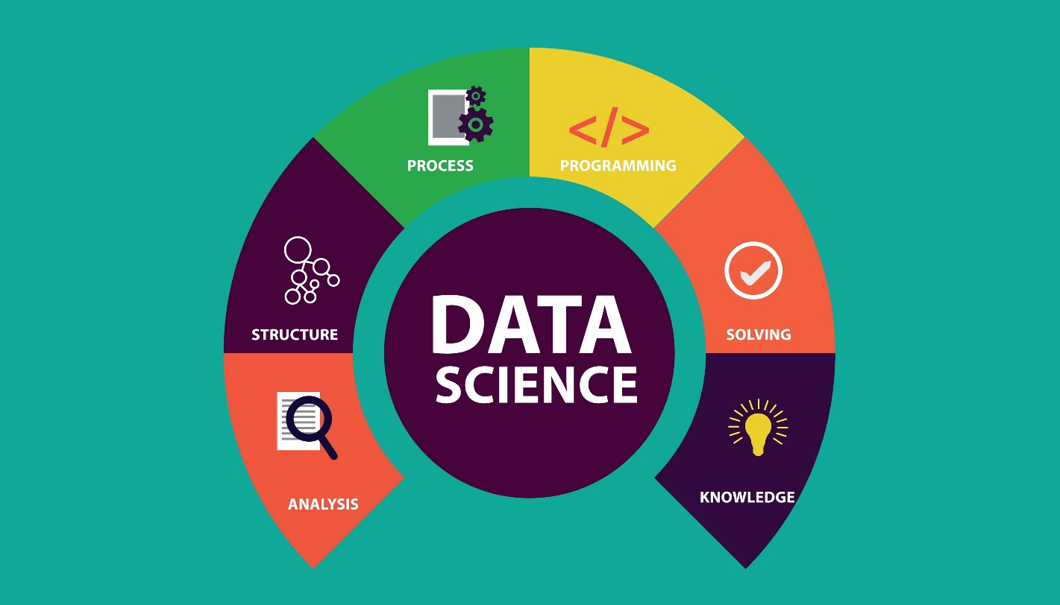
Shutterstock
- Sohaga kirish yo‘llari: Data Sciencega kirishning yagona yo‘li yo‘q. Ko‘pchilik yo‘llar matematika va dasturlashni talab qilsa-da, eng muhimi – ma'lumotlarga bo‘lgan qiziquvchanlikdir.
- Kerakli xislatlar: Yangi Data Scientist quyidagi 3 xislatga ega bo‘lishi shart:
  - Qiziquvchan (Curious): Savol bera oladigan.
  - Mulohazali (Judgmental): Vaziyatni to‘g‘ri baholay oladigan.
  - Bahslashuvchi (Argumentative): O‘z fikrini dalillar bilan asoslay oladigan.
- Talab va Maosh: Bilimli mutaxassislar "qo‘lma-qo‘l" bo‘lib ketmoqda va ularga yuqori maosh to‘lanadi.
- Ish jarayoni: Data Scientistning odatiy ish kuni bir xil bo‘lmaydi, u ishlayotgan loyiha turiga qarab o‘zgarib turadi.
- Asosiy vositalar: Ma'lumotlardan ma'no chiqarish uchun ko‘plab algoritmlar ishlatiladi.
- O‘rganilgan atamalar: Siz dars davomida quyidagi muhim terminlarni o‘zlashtirdingiz:
  - Outliers: Ajralib qolgan g'ayritabiiy qiymatlar.
  - Model: Voqelikning matematik ko'rinishi.
  - Algorithms: Muammoni yechish ketma-ketligi.
  - JSON, XML, CSV: Ma'lumot saqlash formatlari (Siz bularni Web dasturlashdan yaxshi bilasiz).
  - Regression: Bog'liqlikni aniqlovchi statistik model.
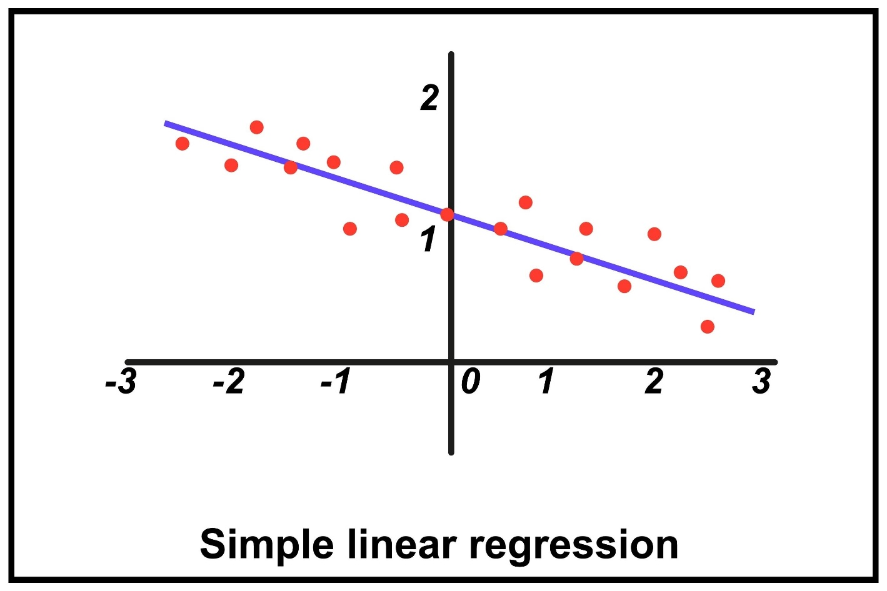
Keyingi qadam: Birinchi dovondan oshdingiz. Endi poydevoringiz bor, keyingi darslarda chuqurroq mavzularga kirishasiz. Olg'a!

